Custom Built Capital Markets Assumptions Framework and Strategic Asset Allocation for US Life Insurers
Giga Nozadze

Why The Industry Focuses on the Wrong Kind of Risk
Long term allocators like life insurers, pensions, endowments, and sovereign funds invest in different worlds. Endowments and SWFs can afford long dated, illiquid bets. Life insurers, by contrast, operate under capital rules, manage long dated liabilities, and keep most of their money in fixed income. Their investment horizon isn’t quarterly, it’s closer to ten or twenty years. So they need capital market assumptions that actually fit that horizon.
This project steps back from the usual toolkit to ask: what do we really need to know about risk and return over the long run? For fixed income, the answer is starting yield adjusted for credit loss, because it consistently explains the bulk of future returns. For equities, I use cash based components like dividends and buybacks, plus long term growth and valuation views, built bottom up by sector. Private assets follow the same idea: de smooth reported returns and look at economic drivers.
Instead of using volatility as a risk proxy, I define risk as the forecast error around long run return assumptions. That distinction matters. Insurers usually hold assets to maturity, so mark to market noise is just that, noise. What matters more is how wrong the assumptions might be over a decade. The framework here aims to be practical and forward looking. All this leads to my suggested optimal allocations for six US life insurers that are different from their current portfolios, and the rest of the paper goes into details and mechanics of how I build and optimize them.

Fixed Income
All data used is sourced from Bloomberg, capturing flexible yet relatively constant maturity index time series data. Yield to Worst (YTW) series data were collected monthly from 1980 up to June 30, 2025 for the following indices:
 | Asset
Government | US Treasuries, Short/Intermediate
Government | US Treasuries, Long
Government | US Taxable Munis
Government | Global ex-US Government, hedged
Public Corporates | US Public Corporates IG AAA
Public Corporates | US Public Corporates IG AA
Public Corporates | US Public Corporates IG A
Public Corporates | US Public Corporates IG BBB
Public Corporates | US Public Corporates, HY Intermediate
Public Corporates | US Public Corporates, HY Long
Public Corporates | Global ex-US Corporates, hedged
Structured | Residential Mortgage-Backed Securities
Structured | Commercial Mortgage-Backed Securities
Structured | Asset-Backed Securities
Private Credit | Corporate IG Private Placement A
Private Credit | Corporate IG Private Placement BBB
Private Credit | Corporate HY Private (Leveraged Loans)
Private Credit | Residential Mortgage Whole Loans
Private Credit | Commercial Mortgage Whole Loans
I also have to make a note about the usefulness and validity of my approach here. Although life insurers typically buy and hold individual bonds to maturity rather than trading like an index, using fixed income indices to model expected returns still makes sense because both are governed by the same underlying economics. In either case, long-horizon returns are driven by starting yield and the rates at which coupons are reinvested, with yield curve movements affecting outcomes whether recognized monthly through index rebalancing or through mark-to-market valuations that flow into insurers’ surplus. The index structure simply provides a transparent, market-consistent way to capture these yield and reinvestment dynamics, making it a valid proxy for insurer portfolios in SAA.
In this analysis, I intentionally exclude cash from the expected return modeling framework. Although cash is essential for liquidity management, it does not function as a strategic return driver over extended investment horizons. Empirical and industry research consistently demonstrates that cash historically underperforms risk-bearing assets such as bonds and equities across multi-year periods. Several factors underpin this long-term underperformance:
- Structural return deficiency: bonds allow reliable long-term return forecasting based on starting yields and embedded term premia. Cash, however, lacks such reliability, with short-term interest rates subject to significant fluctuations driven by central bank policy decisions rather than structural macroeconomic drivers such as long-term growth, inflation trends, or persistent risk premia.
- Forecasting limitations: empirically, the autocorrelation of cash return time series (1999-2025) is around 70% vs -10% for longer indices (long UST and corporate IG), the volatility and policy-dependent nature of short-term interest rates severely limits the stability and reliability of long-term cash return projections. Unlike longer-duration assets, cash has no term premium and responds predominantly to short-term monetary cycles rather than fundamental macroeconomic conditions.
- Portfolio role: from a portfolio construction standpoint, cash primarily serves as a liquidity buffer rather than a strategic asset. Institutional investors, particularly life insurers, typically maintain only minimal cash holdings (around 1–2%) to facilitate operational liquidity, meet transactional needs, or temporarily hold funds awaiting deployment into productive assets.
Given these factors, I set a fixed minimal cash allocation of 1%, acknowledging its tactical liquidity role but excluding it from surplus-optimizing strategic decisions. This aligns with typical life insurance investment practices that prioritize capital efficiency and liability matching over unproductive cash holdings.
Foreign Currency Bonds
In my framework, foregn currency bonds are modeled using currency-hedged indexes rather than unhedged ones. The reason is that unhedged exposures introduce large amounts of uncompensated FX volatility, which in many cases dominates the bond return variance, as shown in the chart below. While one could make the case that foreign bonds provide diversification when domestic assets sell off alongside the currency, the evidence suggests that such offsets are weak (correlations are modest, around 0.25) and unstable over time. Moreover, correlation does not imply a reliable causal hedge.
Figure 1: Foreign currency volatility makes up the majority of the unhedged foreign currency bond risk
Life insurers and other institutional allocators do in practice allocate to foreign sovereign and corporate bonds, but on a hedged basis, since their mandate is to capture the bond risk premium rather than currency noise. Following this logic, I include foreign bond exposures in my CMA framework through hedged indexes, ensuring comparability to domestic bonds and aligning with real-world institutional implementation.
Return Estimation
Life insurers earn cash yields on largely buy-and-hold fixed-income books carried at (mostly) amortized cost. Daily mark-to-market noise is not their economic risk; credit impairment and forecast error vs. starting yield are. I therefore anchor expected returns on starting yield (geometric/IRR) and deduct expected credit loss (ECL).
Inputs are starting yield Y_{i}(t) at decision time t (index yield-to-worst) for the sleeve and expected annual credit loss rate ECL_{i}(t) (default * hazard rate × LGD, plus any systematic downgrade/migration haircuts). Y_{i}​ is an IRR/CAGR by construction; it already accounts for compounding (no variance-drag mismatch). Insurers reinvest coupons and maturities to maintain a target duration. I do not forecast the entire future yield curve or path of reinvestment rates. On the expected return side, I assume ups and downs in reinvestment roughly net out over the long horizon. On the risk side, however, reinvestment uncertainty is captured through the RMSE measure, since realized CAGRs reflect whatever reinvestment rates prevailed along the way. This keeps the CMA tractable and aligned with actual insurer practice.

Figure 2: Starting yields are good indicators of actual performance
Credit Loss and Capital Efficiency Adjustments
While Yield to Worst (YTW) serves as a conservative base case for return expectations, assuming the earliest possible redemption scenario, it does not account for credit losses arising from defaults or downgrades. YTW assumes contractual cash flows will be honored, which makes it insufficient for realistic modeling of credit-sensitive portfolios. To reflect this, I apply expected credit loss adjustment, using 10-year cumulative default probabilities by rating tier and assumed Loss-Given-Default (LGD). The figures in the final table are based on long-run Moody’s and S&P data, with assumed LGDs of 60% for corporates and lower for structured products. Sector-level estimates reflect a weighted average of underlying ratings.
Since the analysis is aimed at life insurers’ portfolios, which face probably the highest number of regulations among large institutional asset allocators, I am also adjusting the yields by how much capital drag each asset has, which in public fixed income space is dependent on the credit ratings. The table below shows the list of assets along with their assigned schedule NAIC papers, ratings, NAIC designations, and capital charges (times portfolio adjustment factor which accounts for the number of issuers in a given index, and which I assume to be around 500 for each index I take, with PAF of ~1).
Asset | Schedule | Rating | NAIC Designation | Capital Charge X PAF | Maturity | Duration
US Treasuries, Short/Intermediate | D-1 | AAA | 1A | 0.00% | 4.0 | 3.7
US Treasuries, Long | D-1 | AAA | 1A | 0.00% | 22.1 | 13.8
US Taxable Munis | D-1 | AA | 1C | 0.00% | 13.3 | 10.6
Global ex-US Government, hedged | D-1 | AA | 1C | 0.42% | 9.7 | 8.3
US Public Corporates IG AAA | D-1 | AAA | 1A | 0.16% | 5.4 | 5.0
US Public Corporates IG AA | D-1 | AA | 1C | 0.42% | 7.8 | 6.8
US Public Corporates IG A | D-1 | A | 1F | 0.82% | 10.3 | 8.3
US Public Corporates IG BBB | D-1 | BBB | 2B | 1.52% | 10.5 | 8.2
US Public Corporates, HY Intermediate | D-1 | BB– | 3C | 6.02% | 4.5 | 3.9
US Public Corporates, HY Long | D-1 | BB– | 3C | 6.02% | 16.3 | 9.5
Global ex-US Corporates, hedged | D-1 | A | 1F | 0.82% | 7.0 | 6.2
Residential Mortgage-Backed Securities | D-1 | AA | 1C | 0.00% | 7.8 | 6.7
Commercial Mortgage-Backed Securities | D-1 | AA | 1C | 0.00% | 4.4 | 4.1
Asset-Backed Securities | D-1 | AA | 1C | 0.42% | 3.6 | 3.3
Corporate IG Private Placement A | D-1 | A | 1F | 0.82% | 10.3 | 8.1
Corporate IG Private Placement BBB | D-1 | BBB | 2B | 1.52% | 10.5 | 8.0
Corporate HY Private (Leveraged Loans) | D-1 | B+ | 4A | 7.39% | 4.7 | 3.9
Residential Mortgage Whole Loans | B | AA | 1C | 0.68% | 7.7 | 6.4
Commercial Mortgage Whole Loans | B | AAA | 1A | 0.90% | 4.4 | 4.1
Private Equity | BA | - | - | 30.00%
Real Estate (via partnerships, equity) | BA | - | - | 30.00%
The capital charge drags the expected return as it ties up the capital that could be invested at the hurdle rate for the given company, which is also its cost of capital and I assume to be 10%. The typical RBC ratio (how much capital above the required charge they typically hold for a given asset) for life insurers is 4.
Different Risk Measures
Risk estimation forms a crucial component of the capital market assumptions that inform SAA. I compute three distinct risk metrics for each bond index in my investment universe:
- Traditional Standard Deviation of Returns: Represents the volatility based on the typical yearly fluctuations in bond returns
- Standard Deviation of Long-Term CAGR: Calculated by multiplying the standard deviation of Compound Annual Growth Rates (CAGRs) by the square root of the index’s average maturity, enabling direct comparability with the annualized standard deviation
- Root Mean Square Error (RMSE): Derived from the historical forecasting errors of yield-based return predictions, multiplied by the square root of maturity to align comparably with annualized standard deviation.
The dominant model in classical finance assumes that asset returns are independent and identically distributed (i.i.d.). Under this assumption, the volatility of multi-year returns is derived from short-term volatility by applying the square root of time rule, so the standard deviation of an average annual return over a 10-year period is often modeled as σ_{10Y}=σ_{1Y}×√10.
This rule forms the backbone of models like the Samuelson Invariance Theorem, which implies that optimal asset allocation does not depend on investment horizon. However, this approach ignores several empirically observed patterns:
- Returns are not i.i.d., and they are partially predictable using valuation measures like yields.
- Short-term volatility does not capture long-term uncertainty accurately.
- Certain asset classes, especially hybrid assets like high-yield bonds, preferreds, and REITs, exhibit mean reversion.
Time Diversification and Mean Reversion
Time diversification is the idea that risk declines as the investment horizon lengthens. Just as investors diversify risk by spreading across asset classes, they can also diversify across time if poor short-term outcomes are offset by stronger subsequent returns. In practical terms, this shows up as annualized volatility falling with longer holding periods, because temporary shocks are gradually “washed out” as prices revert and income compounds.
The mechanism behind time diversification is mean reversion. If returns are negatively correlated across time, where weak years are more likely to be followed by stronger ones, then the dispersion of long-run outcomes narrows. For example, a sudden yield spike hurts bond returns in the short run, but over several years bonds pull back to par and coupons are reinvested at higher rates, reversing much of the initial loss. This tendency for deviations to self-correct explains why multi-year holding-period risks can be materially lower than annual volatility would suggest.
Figure 3: Lower deviation in CAGRs compared to annual returns suggest mean reversion in returns, mainly driven by HY bonds, hybrids, and long-term indexes
The effect of mean reversion can be seen in the second (blue) bar: the distribution of CAGRs has a noticeably lower mean and median volatility compared to 1-year returns. Intuitively, this happens because extreme short-term shocks (e.g., a sudden yield spike) wash out over multi-year horizons as bonds converge back toward par and reinvestment rates stabilize. In statistical terms, the standard deviation of CAGRs shrinks relative to 1-year volatility precisely because past deviations are gradually reversed, capturing the essence of mean reversion.
The contrast between the first and second distributions is especially pronounced in long-term, high-yield and structured fixed-income indices, where credit spreads tend to overshoot in the short run but mean-revert more strongly as defaults, recoveries, and structural carry effects play out over the investment horizon.
In the context of long-horizon institutional investing, the concept of time diversification has often been underappreciated or misunderstood, particularly in traditional finance theory. However, for strategic asset allocation (SAA) decisions spanning 10 years or more, these phenomena can play a critical role in risk estimation and portfolio design. The chart below illustrates the concept of time diversification by showing how the annualized volatility of compounded U.S. bond returns declines as the investment horizon lengthens, from 1 to 15 years, across four major fixed income categories: U.S. Treasuries (UST), Investment Grade credit (IG), High Yield credit (HY), and Structured products. The steepest decline is seen in HY and Structured bonds, which exhibit markedly lower volatility at longer holding periods. For instance, HY volatility compresses from 16.4% at a 1-year horizon to just 4.0% over 15 years, a fourfold reduction.
Figure 4: Time diversification effect is most pronounced in HY securities
This empirical behavior is not just statistical coincidence but reflects structural features of credit markets. High yield returns tend to be driven by recurring income streams and cyclical credit re-rating patterns that cancel out over time, producing strong mean-reversion dynamics. Meanwhile, interest rate exposure in structured bonds (often backed by amortizing loans or mortgages) introduces a similarly smoothing mechanism via cash flow-driven price anchoring. In contrast, Treasuries, though lower in absolute volatility, display more muted time diversification, as their returns are tightly tethered to evolving rate expectations with less income cushion.
The declining risk at longer horizons does not stem from serially correlated returns, as classical theory would suggest, but from the fact that long-horizon outcomes are more accurately forecastable based on current yields, reducing forecast dispersion. This phenomenon underscores a profound insight for strategic asset allocators: not all short-term risk translates linearly into long-term risk. Especially in HY and structured credit, the compounding of stable income over time and partial mean-reversion of spread shocks deliver disproportionately lower long-term volatility, supporting higher allocation weights in strategic portfolios with long-duration surplus objectives.
If we compare the traditional (standard error) vs novel (RMSE, not scaled) approaches to how wrong we could be in average return estimation, RMSE beats the Standard Error estimation, with both considerably lower average level and interquartile range.

Figure 5: As expected, RMSE is lower than traditional measure of average return volatility STERR
All this indicates that RMSE provides a more reliable and realistic measure of long-term forecast uncertainty. Also, maturity has an impact predictability: the longer the maturity of an index, the more effectively the starting yield predicts actual returns over a 10-year investment horizon. Shorter-term indices face greater reinvestment risk and yield curve uncertainty due to more frequent rollovers, necessitating robust yield forecasting methods.
It should also be noted that the mean error is positive for long-term indexes, which is because the the sample period starts from 2000, and the very low interest rate regime started after like 10 years from 2000, and that decreasing interest rates makes bonds perform better so from the beginning the actual 10-year CAGR returns are higher than the starting yields. Capital gains from falling rates get locked in for longer because short-term bonds mature quickly, prices pull back to par fast, so gains fade quickly, while long-term bonds don’t mature soon, so price gains stick and investors enjoy elevated returns longer.
These results illustrate how holding period drastically alters perceived risk: short-term volatility paints a much riskier picture than long-term uncertainty justifies. High-yield and structured bonds, often dismissed as too volatile, emerge as attractive candidates for strategic allocations due to their return stabilization over time.
Risk Estimation
Risk is defined as the uncertainty in realized compounded outcomes relative to the forecast, not as mark-to-market volatility. Starting yield-model error exists because of 1) coupon reinvestment risk and 2) credit-loss error, since realized defaults and downgrades can differ from expectations.
For each sleeve i, I form overlapping 10-year cohorts (a new cohort each month) and compute realized 10-year CAGRs from a duration-maintained total-return index:
$$Ri(t →t+10) ={(\frac{I_{i}\left(t+120\right)}{I_{i}\left(t\right)})}^{1/10} - 1$$
where I_{i}(⋅) is the index level. Yield-model forecast error is defined as:
$ϵ_{i,t}^{(y)}=R_{i\left(t →t+10\right)}-Y_{i}(t)$ and ${RMSE}_{i}=\sqrt{\frac{1}{N_{i}}\sum_{t}{({ϵ_{i,t}^{\left(y\right)}}^{2})}}$
RMSE of bond returns, which is basically the measure of "wrongness" in compunded average return of an index (along with all its mean reversion and time diversification) is an appropriate risk measure because of holding to maturity practice and book accouning instead of mark to market. It does not take into account the market swings in interest rates that would introduce the volatility, but it combines two important measure of risk: reinvestment risk and credit risk.
To be comparable to the traditional risk measure of standard deviation, I scale this RMSE by square root of 10. The intuition behing this scaling is that the RMSE number corresponds to the “wrongness” in the average 10-year CAGR, which is comparable to standard error (not standard deviation), and that “smoothed-out” measure should be multiplied by the square root of time horizon. In addition, using a duration-maintained index matches insurer practice, while avoiding explicit reinvestment path modeling.
In this analysis, I assume that this risk measure includes both types of errors mentioned above (reinvestment & credit loss). However, as a final risk measure which I give to my optimizer is the weighted average of long-term uncertainty (scaled RMSE) and short-term risk (historical standard deviation, which more or less stays within the reasonable bounds over time and so is a good proxy for expected volatility). I give former 0.7 and latter 0.3 weight. The reason for this weights are somewhat subjective but dependent on the idea that while life insurance and retirement products liabilities are fairly long-term and can withstand substantial drawdowns, the short-term volatility is still relevant because of regulations (rbc requirements) and liquidity constraints along the way. If it was endowment asset allocation problem, for example, I would give even less weight to short-term volatility, because they have the longest investment horizons and fewest regulatory/board restrictions among institutional asset allocators (pensions, insurance, SWFs), so for them larger drawdowns are tolerable, although maximizing wealth growth also requires high risk-adjusted returns, which itself depends on maximizing compounded returns and relatively moderate drawdowns.
$$σ=0.7*RMSE+0.3*Vol$$
Strategic Implications for SAA
- Risk should not be estimated by volatility alone – the square-root-of-time method overstates long-term risk. RMSE is a better proxy for actual return uncertainty over strategic horizons.
- Mean reversion creates opportunities – HY and structured credit instruments exhibit risk behaviors more consistent with equities over long holding periods. Their inclusion in a life insurer’s portfolio can enhance long-term Sharpe ratios.
- Duration enhances forecast accuracy – the predictive power of starting yield strengthens with bond maturity. This justifies overweighting longer-duration assets in liability-aware frameworks.
- Time diversification is real but conditional – the benefits are most pronounced when:
  - Starting valuations (e.g., yields) are used to forecast returns;
  - Investors are not forced to liquidate prematurely (i.e., drawdown-insensitive);
  - Leverage is managed conservatively.
- Policy implication – a rational, forecast-driven allocator should redefine risk as “uncertainty of hitting long-term targets,” not year-to-year volatility. This redefinition justifies strategic allocations that might appear aggressive under traditional risk metrics.
Based on all of the above, the final return and risk estimation figures are given below.
Figure 6: Expected return and risk of fixed income indexes

Public Equity
This section provides a comprehensive explanation of the methodology, rationale, and data inputs used to estimate strategic long-term expected returns for U.S. equities within the Strategic Asset Allocation (SAA) framework. Unlike traditional top-down approaches, which often rely on index-level heuristics or aggregate macro projections, this analysis adopts a granular bottom-up structure, designed to be both cash-flow based and valuation-sensitive, while integrating structural economic insights and historical data patterns. Each step of the equity CMA construction reflects an effort to align financial modeling with the actual behaviors of public companies, equity markets, and sector-specific business models over time.
To begin with, the scope of the equity analysis is intentionally narrowed to U.S. large-cap equities only, and more specifically, to the eleven GICS sectors within the S&P 500 index. The rationale for this focused approach stems from both methodological and operational considerations:
- Bottom-up equity modeling at the sector level requires extensive historical data collection for constituent firms, including detailed variables such as dividends, buybacks, and growth estimates.
- Expanding this framework to multiple geographies or indices would have proven logistically prohibitive and would risk compromising the rigor of the estimation.
- Restricting the analysis to the U.S. large-cap equity universe avoids the complications of FX forecasting and cross-border tax and liquidity assumptions.
Historical data from Bloomberg were collected for all eleven sector-specific equity indices from 2003 to 2025, specifically the Bloomberg tickers corresponding to each sector such as B500CT (Consumer Staples), B500E (Energy), B500I (Industrials), and so forth. The monthly time series included index level prices, dividend yields, trailing-twelve-month (TTM) earnings per share (EPS), price-to-earnings (P/E) ratios, and net profit margins. This multi-decade data foundation ensures a sufficiently long observation window to capture both cyclical and structural patterns, including periods of economic expansion, contraction, and crisis.
The foundational component of the expected return estimation is the concept of a "cash yield," the equity market's closest analog to a bond's starting yield. Accounting earnings can be systematically manipulated and often diverge from the underlying economic reality that investors should rely on, making cash-based measures significantly more robust. Academic literature and regulatory commentary consistently highlight that companies frequently engage in earnings management through accrual adjustments, one-off items, or strategic timing of expenses and revenues, which distorts reported earnings quality. Earnings may reflect accounting judgment rather than actual cash flows, rendering traditional P/E or EPS-based return models vulnerable to these distortions. In contrast, empirical evidence suggests that shareholder yield components, dividends and buybacks, are harder to manipulate and better reflect real cash returned to investors. Dividend-paying stocks, on average, exhibit lower return volatility, even when controlling for firm size, indicating that cash distributions are associated with greater stability and transparency. Moreover, accrual-based earnings quality improves only when internal controls are strong, otherwise companies may still distort earnings figures even in ostensibly well-governed firms. These findings reinforce the superiority of using cash-based yields as forward return anchors in equity return modeling framework, dividends and buybacks cannot be fabricated, they reflect real value returned to shareholders, and they are less subject to managerial discretion or manipulation.
For equities, this is defined as the sum of dividend yield and share buyback yield. While dividend yield data are readily available at the sector index level, buyback data is not directly accessible in aggregated form. To overcome this, a bottom-up methodology was employed:
- For each year-end, the constituent companies of every sector index were retrieved via Bloomberg's Excel API.
- Key data included market capitalization, share prices, shares outstanding, and actual buyback amounts.
- These values were used to compute market-capitalization-weighted buyback yields at the sector level, creating a robust and replicable proxy for shareholder yield.
Figure 7: Buyback yields have considerably increased since 2012
Over the past two decades, share buybacks have become a structurally important component of shareholder return policy across nearly all U.S. equity sectors. As illustrated in the chart, buyback yields were negligible or even negative during the early 2000s but began rising meaningfully post-2010, with an especially sharp acceleration following the 2017 corporate tax reform and the COVID-19 recovery period. By 2022–2025, many sectors, including Financials, Technology, and Industrials, consistently delivered buyback yields in the 3% to 6% range, rivaling or exceeding their dividend yields. This shift reflects a broader transformation in corporate capital allocation strategies, where buybacks have become the preferred mechanism for returning cash to shareholders due to their flexibility, tax efficiency, and perceived signaling value. The growing prominence and persistence of buyback activity underscore the need to incorporate them explicitly into any forward-looking equity return model, particularly for sector-level strategic allocation analysis.
An important technical adjustment was made to both dividend and buyback yields to better reflect the timing of cash distributions. Specifically, raw dividend yield figures, which are calculated based on the year-end index level, were adjusted by dividing by the average index level over the course of the preceding year. This correction accounts for the fact that dividends and buybacks are distributed throughout the year rather than as a single lump sum at year-end, improving the fidelity of the cash yield as an annualized figure.
To estimate forward growth, 5-year consensus EPS growth forecasts were constructed using Capital IQ data. As these forecasts were not available in aggregate at the sector index level, another bottom-up process was employed:
- For each year-end in the historical period, EPS growth expectations were retrieved for all constituent companies in each sector, if available (they were available for majority of index constituents all of the time).
- These forecasts were then market-cap weighted to arrive at a sector-level forward growth rate.
- It is assumed that the growth in cash yield (dividends and buybacks) matches EPS estimated growth rate.
With both cash yield and expected growth in hand, the next step involved computing the implied cost of equity for each sector at each year using a two-stage dividend discount model, a version of the Gordon Growth Model. The structure of the model includes an initial five-year phase of elevated growth, followed by a perpetual growth phase at a lower terminal rate. The formula applied is as follows:
$$P= ∑_(t=1)^5▒〖D_0 (1+g)〗^t/(1+r)^t + (D_0 (1+g)^5 (1+g_term ))/((r-g_term ) (1+r)^5 )$$
- P is the index level at year-end
- D₀ is the current cash yield (dividends + buybacks)
- g is the 5-year EPS growth rate
- rfr is the terminal growth rate (set equal to the long-term risk-free rate)
- r is the cost of equity to be solved for
This nonlinear equation was solved using a VBA-automated goal-seek macro to determine the implied cost of equity for each sector and year. After obtaining the implied cost of equity, the long-term risk-free rate was subtracted to derive the implied equity risk premium (ERP), the primary input into the SAA model. The choice of using the long-term rate (long treasury index) as the discount rate and terminal growth assumption is consistent with equity’s long-duration nature, as equities represent claims on a very long stream of future cash flows.
Figure 8: Implied ERP levels have been more volatile in the last decade
The chart below plots the evolution of implied ERP by sector over the 2004–2025 period. The series are highly dynamic, influenced by fluctuations in valuation, payout behavior, and forward growth expectations. Notably, a pronounced upward shift in implied ERP levels is visible post-2015 across most sectors, with a further spike during periods of market stress, including 2020 and late 2023. These ERP movements capture not just investor sentiment and risk appetite, but also cyclical inflections in fundamentals and pricing.
Beliefs about market efficiency inherently shape how equity risk premiums are estimated. For long-horizon allocators, the choice of methodology reflects underlying assumptions about whether markets are efficiently priced. If one believes that public markets are broadly efficient over time, or at least that their direction is inherently unpredictable, then the current implied equity risk premium (ERP), derived from prevailing market prices and cash flows, offers the most rational anchor for return expectations. However, if one sees recurring valuation dislocations or structural inefficiencies at the sector or macro level, then using longer-term average implied ERPs or even historical realized premiums may be more appropriate. Survey-based ERPs, while occasionally used, may be preferred only by those who lack confidence in market-based signals altogether.
Since this framework is designed primarily with institutional allocators in mind, and I believe in general market efficiency with some sector-level inefficiencies, the implied ERP is adopted as the core signal, which is then refined through valuation-aware and structurally-informed adjustments, as described in the subsequent CAPE-based and profitability-based enhancements.
Having established base return expectations using implied cost of equity (implied ERP + long-term riskfree rate), the next step introduces a valuation-sensitive overlay via sector-specific CAPE adjustments. The cyclically adjusted P/E ratio (CAPE) serves as a signal of valuation deviation from historical norms. The methodology here avoids simplistic valuation heuristics and instead uses a regression-based framework to determine whether CAPE ratios have explanatory power for future sector-level excess returns. Rolling regressions were performed for each sector, regressing subsequent 5-year excess returns on CAPE deviations from historical norms. Three sub-periods were evaluated:
- The full historical sample
- The post-GFC expansion (2009–2015)
- The more recent cycle (2015–2020)
Only when these regressions exhibited meaningful explanatory power, defined as an R-squared above 0.2 in at least one sub-period, was an adjustment applied. The size of the adjustment was proportional to the statistical significance and stability of the relationship:
- If both long- and short-term regressions showed strong fit, a full adjustment of the implied excess return was imposed.
- If only one period met the criteria, a smaller 25 to 50 percent adjustment was applied.
- In sectors where CAPE-return linkages were weak or unstable, no adjustment was made.
- In sectors undergoing structural change, such as Information Technology, greater emphasis was placed on recent regressions to reflect evolving valuation paradigms.
The regression charts for each sector are given below (blue dots represent time period 2009-2015, red dots are for 2015-2020, while black line represents the full sample).
The CAPE adjustment process led to the following modifications:
- Technology and consumer staples received a slight upward adjustment due to persistent undervaluation relative to realized performance.
- Industrials and Utilities saw downward adjustments due to persistent overvaluation and a historically robust connection between high CAPEs and poor forward returns.
The output tables for all three testing period regressions are given below:
2009-2015 | consumer_staples | industrials | information_technology | utilities
Alpha | -0.0373 | 0.0190 | -0.0035 | -0.0022
p-value | 0.0000 | 0.0000 | 0.6075 | 0.3927
Beta | -0.0067 | -0.0065 | -0.0113 | 0.0013
p-value | 0.0027 | 0.0000 | 0.0000 | 0.1227
R-squared | 0.119 | 0.697 | 0.372 | 0.034
CAPE deviation (x) | 0.00 | 0.00 | 0.00 | 0.00
Implied excess return (y) | -3.73% | 1.90% | -0.35% | -0.22%
2015-2020 | consumer_staples | industrials | information_technology | utilities
Alpha | -0.0544 | -0.0106 | 0.1033 | 0.0306
p-value | 0.0000 | 0.0000 | 0.0000 | 0.0042
Beta | -0.0061 | -0.0063 | -0.0096 | -0.0098
p-value | 0.0001 | 0.0000 | 0.0000 | 0.0000
R-squared | 0.210 | 0.429 | 0.683 | 0.399
CAPE deviation (x) | 0.00 | 0.00 | 0.00 | 0.00
Implied excess return (y) | -5.44% | -1.06% | 10.33% | 3.06%
Entire period | consumer_staples | industrials | information_technology | utilities
Alpha | -0.0494 | 0.0052 | 0.0685 | -0.0094
p-value | 0.0000 | 0.0038 | 0.0000 | 0.0005
Beta | -0.0085 | -0.0078 | 0.0002 | -0.0036
p-value | 0.0000 | 0.0000 | 0.8855 | 0.0000
R-squared | 0.287 | 0.517 | 0.000 | 0.285
CAPE deviation (x) | -9.84 | 9.84 | 9.71 | 7.46
Implied excess return (y) | 3.41% | -7.12% | 7.06% | -3.63%
Finally, a third layer of refinement was applied to expected returns based on structural sector-specific trends in profitability and margins. These adjustments recognize that valuation-based models such as CAPE, while informative, do not always capture evolving fundamentals, particularly when sector economics are undergoing transformation or degradation.
- Real Estate was adjusted downward by 50 basis points due to a sustained decline in sector-wide net profit margins, which have fallen to levels last seen during the Global Financial Crisis. Net margins now hover around 11.9 percent, down nearly 12 points from their 2015 peak, with a negative annual trend of minus 1.83 percent. Structural pressures include higher interest rates compressing cap rate spreads and secular weakening of office and retail segments.
- Communication Services received a 50 basis point upward adjustment. Net margins have expanded consistently, reaching 19.2 percent in 2025, nearly double the average from a decade prior. This improvement stems from a sectoral shift toward scalable, digital platform companies.
- Utilities were adjusted upward by 25 basis points, supported by a secular rise in profitability to 14.4 percent, driven by inflation-linked rate bases, electrification demand, and renewable energy investment.
Figure 9: Net profit margins by sector
Together, the methodology outlined above represents a rigorous, data-intensive, and forward-looking approach to equity return forecasting. By anchoring expectations in actual cash flows, layering in valuation and structural considerations, and avoiding reliance on simplistic heuristics or backward-looking averages, this framework aims to produce credible, institutionally relevant return forecasts for use in long-horizon strategic allocation decisions.
Risk Estimation
The chart below compares the 10-year scaled root mean square error (RMSE × √10) of return forecasts to the historical standard deviation of total returns for each sector. RMSE here is calculated based on the forecast error between the modeled expected return (implied cost of equity) and the realized return over rolling 5-year periods, and then scaled by √10 to represent volatility over a strategic 10-year horizon, consistent with the time frame of our SAA optimization. This scaling adjusts for the fact that forecast errors over time are not necessarily i.i.d., but it still offers a more forward-looking, model-anchored estimate of risk than raw historical volatility.
Figure 10: RMSE vs Standard Deviation
Notably, in some sectors, specifically Communication Services, Consumer Discretionary, Health Care, and Information Technology, the RMSE actually exceeds the observed standard deviation of returns. This counterintuitive outcome suggests that for these sectors, return forecasts have historically exhibited higher miss errors than the typical annual price fluctuation, which may reflect structural shifts, model misspecification, or simply the inherent difficulty in forecasting sectors undergoing rapid transformation. Conversely, more stable sectors like Consumer Staples, Utilities, and Real Estate exhibit RMSEs that are meaningfully lower than their historical volatilities, underscoring the higher accuracy and reliability of forecast models in those segments.
Despite these nuances, RMSE remains the preferred measure of risk in this SAA framework. It directly reflects the historical uncertainty of our modeled expected return inputs, rather than backward-looking price fluctuations, making it more consistent with a forward-driven optimization approach. This methodological choice ensures internal consistency between return assumptions and risk estimates.
Based on all of the above, the final return and risk estimation figures are given below:
Sector | Implied ERP | CAPE adjustment | Structural adjustment | Expected return | Risk
Communication | 6.01% |  | 0.50% | 6.51% | 27.27%
Consumer discretionary | 3.22% |  |  | 3.22% | 25.89%
Consumer staples | 4.06% | 0.85% |  | 4.91% | 9.40%
Energy | 11.13% |  | -0.50% | 10.63% | 18.68%
Financials | 5.27% |  |  | 5.27% | 14.22%
Real estate | 4.27% |  |  | 4.27% | 6.86%
Health care | 7.62% |  |  | 7.62% | 20.58%
Industrials | 4.59% | -3.56% |  | 1.03% | 14.88%
Materials | 15.44% |  |  | 15.44% | 5.54%
Information technology | 3.18% | 5.16% |  | 8.34% | 33.15%
Utilities | 3.33% | -0.91% | 0.25% | 2.67% | 8.79%

Private equity
I view the expected return profile of private equity relative to public markets through the lens of factor exposures. Buyout strategies, which dominate the private equity universe, systematically load more heavily on certain risks than public equities. Because leverage is central to the buyout model, PE portfolios effectively run at higher equity betas, closer to 1.2–1.5 in practice rather than the sub-1.0 estimates implied by smoothed NAVs. This means the true risk is higher than what reported returns suggest, and that risk tends to show up in prolonged bear markets rather than in short, sharp drawdowns.
The illiquidity angle is more nuanced. In theory, locking capital for 5–10 years should command a premium, but in practice, much of it is competed away. Many investors seem content to trade off some economic compensation in exchange for smoother reported returns and the reduced headline volatility that comes with appraisal-based valuations. As a result, the realized illiquidity premium often looks small or even nonexistent.
The industry track record also points to little evidence of persistent net alpha. Several large-sample studies find that, once you control for leverage, small-cap exposure, and fees, private equity returns are largely explained by traditional risk factors. In other words, the outperformance often attributed to manager skill or illiquidity premia is better understood as compensation for bearing higher equity beta and structural tilts. Fees in particular eat up much of the gross excess return, making it difficult to justify a positive “alpha” at the asset-class level.
Beyond leverage, private equity tends to tilt toward smaller and historically cheaper companies. The small-cap bias is visible in the typical characteristics of buyout targets, while the value bias has become less consistent in recent years as entry multiples have risen. Taking these exposures together, I think it is most realistic to treat private equity as a leveraged small-cap equity exposure, with higher sensitivity to the equity risk premium, some residual size tilt, and no persistent net alpha after fees.
For my expected return modeling, I primarily use a discounted cash-flow framework similar to AQR’s yield-based approach: I start from an estimate of the unlevered return (income yield plus real growth), then add the effects of financial leverage, conservatively account for potential multiple expansion, and subtract fees. This makes the drivers of PE returns more transparent and allows me to stress-test assumptions around valuations, leverage costs, and growth. That said, I also supplement this analysis with a simpler public-equity-based comparison, where I treat private equity as a leveraged small-cap exposure with no net alpha. Using this as a cross-check provides an additional perspective and helps ensure that my forward-looking assumptions remain grounded against public market benchmarks.
In constructing my CMA inputs, I use arithmetic mean expected returns rather than geometric, since arithmetic returns are the appropriate measure for portfolio optimization and strategic asset allocation, they represent the expectation of a one-period return and avoid deducting variance drag, which the optimizer already accounts for through the volatility input. Reported geometric means, while more intuitive for compounding, understate the inputs required for allocation modeling. For the cash or risk-free rate, I do not rely on today’s short-term SOFR or T-bill yield, which are cyclical and unsuitable for a strategic horizon. Instead, I assume a long-run real cash rate (anchored by historical averages and central bank estimates of the neutral rate) combined with long-term inflation expectations from breakeven markets, ensuring consistency with a 10-year investment horizon.

y_{u} | g_{u} | r_{u} = y_{u} + g_{u} | D/E | k_{d} | r_{l} = r_{u} + (D/E)*(r_{u} - k_{d}) | m | r_{g} = r_{l} + m | f | r_{r} = r_{g} - f | i | r = r_{r} + i
Income Yield | Real Growth Rate | Real Unlevered Return | Debt to Equity | Real Cost of Debt | Real levered Return | Multiple Expansion | Gross Real Expected Return | Fees | Net Expected Real Return | Expected Inflation | Net Expected Return
3.6% | + 3.0% | = 6.6% | 52.0% | 3.1% | 8.4% | + 0.3% | = 8.7% | -4.0% | = 4.7% | + 2.3% | = 7.0%
Income Yield – I collected data on recent private equity transactions from Bloomberg and focused on last-twelve-month deal multiples. Since direct earnings yields weren’t available, I used transaction value to EBIT (TV/EBIT) ratios as a proxy. For most deals, these figures weren’t automatically downloadable, so I retrieved them manually for around 200 companies. I then averaged the inverse of these ratios to estimate an income yield for PE, which came out to about 3.6%.
Growth Rate – To capture the real growth potential of PE portfolios, I assumed an unlevered real growth rate of 3.0%, which is about twice as high as the same metric for public markets (Russell 2000 estimated EPS growth rate). The reasoning is that private equity managers can add value through operational improvements, margin expansion, and concentration in higher-growth sectors.
Leverage – I applied a debt-to-equity ratio of 52%, interpolated from post-2008 LBO data and reflecting today’s more conservative financing because of high cost of debt. Leveraging the unlevered return (6.6%) with this D/E and a real cost of debt of 3.1% raises the real levered equity return to about 8.4%. The logic is standard corporate finance: equity holders benefit from borrowing so long as operating returns exceed the interest cost.
Real Cost of Debt – I estimate the real cost of debt as real cash rate (nominal SOFR-expected inflation) + one-third of the HY OAS, averaged over the last year to match how I average purchase multiples. The logic is: most LBO debt is floating-rate secured bank debt; a practical proxy for its spread is about two-thirds of the HY OAS, but issuers don’t effectively pay the full stated spread once you account for default losses borne by lenders. So I haircut the spread by half, which leaves ~one-third of HY OAS added to real LIBOR. I also ignore the interest tax shield (jurisdictions vary), which biases k_{d} slightly up, but that’s offset by the conservative haircut I already apply to the spread.
Multiple Expansion – I added a conservative adjustment of +0.3% for multiple expansion. This reflects the possibility that PE managers, through active ownership and timing of exits, can sell companies at somewhat higher valuation multiples than entry. I floor this component at zero, consistent with AQR’s skeptical stance, and only allow for a small partial convergence toward public market multiples.
Fees – I subtracted 4.0% to reflect management and performance fees. This haircut is somewhat below AQR’s 5.7% historical average, since I expect net performance fees to be lower going forward as returns compress. Even so, the fee drag remains the single largest deduction in the framework.
Inflation Adjustment – Finally, I added back expected inflation of 2.3% to convert from real to nominal returns, yielding a net nominal expected return of roughly 7.0%.

Real Estate
NOI yield | CapEx (~NOI/3) | Cashflow yield | Real growth | Unlevered real ER | Expected inflation | Unlevered nominal ER
4.7% | - 1.6% | = 3.1% | + 0.0% | = 3.1% | + 2.3% | = 5.4%
NOI Yield – I begin with the net operating income yield, which reflects rental income as a percentage of property market value. This is the steady income stream that properties generate before accounting for maintenance costs. It is analogous to a gross yield, similar in spirit to a dividend yield in equities but based on property-level cashflows.
CapEx Deduction – From NOI, I subtract recurring capital expenditures. These are the costs required to maintain and preserve the property’s income-generating capacity. Empirical work (e.g., Pagliari 2017) shows that these expenditures typically average about one-third of NOI. In my case, that adjustment reduces the yield by 1.56%.
Cashflow Yield – The result is the free cashflow yield, representing the actual income available to investors after maintaining the property. This measure is more relevant than raw NOI because it accounts for the fact that real estate is capital-intensive and requires continual upkeep. At this stage, my unlevered real cashflow yield is 3.13%.
Real Growth – For growth assumptions, I use a conservative real growth rate of zero. While rents may rise with GDP or demographics, long-term evidence suggests that real estate income growth has often barely kept up with inflation, or, in some cases, underperformed it. This assumption is consistent with AQR’s treatment of private real estate, where the long-run real growth contribution is taken as negligible.
Unlevered Real Expected Return – By combining the free cashflow yield and the real growth assumption, I arrive at an unlevered real expected return of 3.13%. This reflects the baseline compensation investors can expect before inflation and leverage, directly from property-level economics.
Inflation – To convert to nominal terms, I add expected inflation. Here, I assume 2.28%, which captures the anticipated erosion of purchasing power over time. This step aligns real estate projections with nominal return frameworks used in portfolio construction.
Unlevered Nominal Expected Return – Finally, adding inflation to the unlevered real expected return yields a nominal expected return of 5.41%. This is the figure I use for strategic asset allocation purposes, providing a consistent basis of comparison with public equities and fixed income.

Correlations and Variance/Covariance
In building the variance–covariance matrix for my optimizer, I take a different path from the usual volatility-driven framework. Rather than starting with historical standard deviations, I first define risk measures that reflect the long-term economic properties of each asset class. For public fixed income indices, this comes from excess return distributions.
For private equity, I rely on two complementary approaches: a yield-based build that stacks up income yield, growth, leverage, and fees; and a public proxy that scales Russell 2000 excess returns by a leverage factor to capture the higher beta of buyouts. For private real estate, I combine a cashflow-based expected return (NOI less CapEx plus inflation) with a listed REIT proxy that reflects the true volatility and market co-movement of the asset class, as appraisal-based indices are too smooth. In each case, the “σ” I use is my own forward-looking risk measure, not simply a sample standard deviation.
To capture how these asset classes move together, I calculate correlations directly from the proxy return series. All returns are expressed in excess form to ensure comparability across equities, bonds, and alternatives. For private equity, that means excess returns from a levered Russell 2000 series; for private real estate, excess returns from REITs; and for other public asset classes, excess returns from their respective indices. With these monthly series, I estimate the correlation matrix empirically. Finally, I combine these correlations with my custom risk measures using the standard covariance identity:
$${Cov}_{i,j}=ρ_{i,j}*σ_{i}*σ_{j}$$
This way, the covariance matrix preserves the realistic cross-asset co-movement that emerges from market data, while its diagonal elements reflect the non-standard, horizon-matched risks that I believe are more appropriate for long-term allocators. The result is a covariance structure that ties together consistent forward-looking returns, risks, and correlations for public markets, private equity, and private real estate in a unified framework.
The final variance/covariance matrix is given below:

 | US Treasuries, Short/Intermediate | US Treasuries, Long | US Taxable Munis | Global ex-US Government, hedged | US Public Corporates IG AAA | US Public Corporates IG AA | US Public Corporates IG A | US Public Corporates IG BBB | US Public Corporates, HY Intermediate | US Public Corporates, HY Long | Global ex-US Corporates, hedged | Residential Mortgage-Backed Securities | Commercial Mortgage-Backed Securities | Asset-Backed Securities | Corporate IG Private Placement A | Corporate IG Private Placement BBB | Corporate HY Private (Leveraged Loans) | Residential Mortgage Whole Loans | Commercial Mortgage Whole Loans | Private Equity | Real Estate (via partnerships, equity)
US Treasuries, Short/Intermediate | 1.0 | 0.9 | 0.5 | 0.8 | 0.9 | 0.7 | 0.6 | 0.5 | 0.0 | 0.1 | 0.7 | 0.8 | 0.2 | 0.3 | 0.2 | 0.1 | -0.4 | 0.2 | 0.2 | 0.0 | 0.0
US Treasuries, Long | 0.9 | 1.0 | 0.6 | 0.8 | 0.9 | 0.8 | 0.6 | 0.5 | 0.0 | 0.1 | 0.7 | 0.8 | 0.2 | 0.3 | 0.2 | 0.2 | 0.3 | 0.2 | 0.2 | 0.0 | 0.0
US Taxable Munis | 0.5 | 0.6 | 1.0 | 0.7 | 0.7 | 0.7 | 0.7 | 0.7 | 0.5 | 0.5 | 0.6 | 0.7 | 0.4 | 0.6 | 0.3 | 0.3 | 0.2 | 0.5 | 0.4 | 0.0 | 0.0
Global ex-US Government, hedged | 0.8 | 0.8 | 0.7 | 1.0 | 0.8 | 0.8 | 0.7 | 0.6 | 0.2 | 0.3 | 1.0 | 0.8 | 0.3 | 0.3 | 0.3 | 0.2 | -0.1 | 0.4 | 0.3 | 0.0 | 0.0
US Public Corporates IG AAA | 0.9 | 0.9 | 0.7 | 0.8 | 1.0 | 0.9 | 0.7 | 0.6 | 0.2 | 0.3 | 0.6 | 0.9 | 0.4 | 0.4 | 0.3 | 0.2 | 0.4 | 0.5 | 0.4 | 0.0 | 0.0
US Public Corporates IG AA | 0.7 | 0.8 | 0.7 | 0.8 | 0.9 | 1.0 | 1.0 | 0.9 | 0.5 | 0.6 | 0.6 | 0.8 | 0.5 | 0.5 | 0.4 | 0.4 | 0.4 | 0.5 | 0.5 | 0.0 | 0.1
US Public Corporates IG A | 0.6 | 0.6 | 0.7 | 0.7 | 0.7 | 1.0 | 1.0 | 0.9 | 0.6 | 0.7 | 0.6 | 0.7 | 0.6 | 0.6 | 0.4 | 0.4 | 0.4 | 0.5 | 0.6 | 0.1 | 0.1
US Public Corporates IG BBB | 0.5 | 0.5 | 0.7 | 0.6 | 0.6 | 0.9 | 0.9 | 1.0 | 0.8 | 0.8 | 0.6 | 0.6 | 0.6 | 0.7 | 0.5 | 0.5 | 0.4 | 0.5 | 0.6 | 0.0 | 0.0
US Public Corporates, HY Intermediate | 0.0 | 0.0 | 0.5 | 0.2 | 0.2 | 0.5 | 0.6 | 0.8 | 1.0 | 0.9 | 0.2 | 0.3 | 0.7 | 0.6 | 0.5 | 0.5 | 0.8 | 0.5 | 0.7 | 0.0 | 0.1
US Public Corporates, HY Long | 0.1 | 0.1 | 0.5 | 0.3 | 0.3 | 0.6 | 0.7 | 0.8 | 0.9 | 1.0 | 0.2 | 0.4 | 0.7 | 0.6 | 0.5 | 0.5 | 0.8 | 0.5 | 0.7 | 0.0 | 0.1
Global ex-US Corporates, hedged | 0.7 | 0.7 | 0.6 | 1.0 | 0.6 | 0.6 | 0.6 | 0.6 | 0.2 | 0.2 | 1.0 | 0.7 | 0.7 | 0.7 | -0.1 | -0.1 | -0.1 | 0.4 | 0.4 | -0.2 | -0.2
Residential Mortgage-Backed Securities | 0.8 | 0.8 | 0.7 | 0.8 | 0.9 | 0.8 | 0.7 | 0.6 | 0.3 | 0.4 | 0.7 | 1.0 | 0.3 | 0.4 | 0.2 | 0.2 | 0.0 | 0.5 | 0.3 | 0.0 | 0.0
Commercial Mortgage-Backed Securities | 0.2 | 0.2 | 0.4 | 0.3 | 0.4 | 0.5 | 0.6 | 0.6 | 0.7 | 0.7 | 0.7 | 0.3 | 1.0 | 0.4 | 0.5 | 0.4 | 0.0 | 0.5 | 1.0 | 0.0 | 0.2
Asset-Backed Securities | 0.3 | 0.3 | 0.6 | 0.3 | 0.4 | 0.5 | 0.6 | 0.7 | 0.6 | 0.6 | 0.7 | 0.4 | 0.4 | 1.0 | 0.5 | 0.4 | 0.0 | 0.5 | 0.5 | 0.0 | 0.1
Corporate IG Private Placement A | 0.2 | 0.2 | 0.3 | 0.3 | 0.3 | 0.4 | 0.4 | 0.5 | 0.5 | 0.5 | -0.1 | 0.2 | 0.5 | 0.5 | 1.0 | 1.0 | 0.7 | 0.5 | 0.5 | 0.2 | 0.2
Corporate IG Private Placement BBB | 0.1 | 0.2 | 0.3 | 0.2 | 0.2 | 0.4 | 0.4 | 0.5 | 0.5 | 0.5 | -0.1 | 0.2 | 0.4 | 0.4 | 1.0 | 1.0 | 0.7 | 0.5 | 0.4 | 0.1 | 0.2
Corporate HY Private | -0.4 | 0.3 | 0.2 | -0.1 | 0.4 | 0.4 | 0.4 | 0.4 | 0.8 | 0.8 | -0.1 | 0.0 | 0.0 | 0.0 | 0.7 | 0.7 | 1.0 | 0.4 | 0.4 | 0.7 | 0.4
Residential Mortgage Whole Loans | 0.2 | 0.2 | 0.5 | 0.4 | 0.5 | 0.5 | 0.5 | 0.5 | 0.5 | 0.5 | 0.4 | 0.5 | 0.5 | 0.5 | 0.5 | 0.5 | 0.4 | 1.0 | 1.0 | 0.4 | 0.3
Commercial Mortgage Whole Loans | 0.2 | 0.2 | 0.4 | 0.3 | 0.4 | 0.5 | 0.6 | 0.6 | 0.7 | 0.7 | 0.4 | 0.3 | 1.0 | 0.5 | 0.5 | 0.4 | 0.4 | 1.0 | 1.0 | 0.0 | 0.2
Private Equity | 0.0 | 0.0 | 0.0 | 0.0 | 0.0 | 0.0 | 0.1 | 0.0 | 0.0 | 0.0 | -0.2 | 0.0 | 0.0 | 0.0 | 0.2 | 0.1 | 0.7 | 0.4 | 0.0 | 1.0 | 0.7
Real Estate (via partnerships, equity) | 0.0 | 0.0 | 0.0 | 0.0 | 0.0 | 0.1 | 0.1 | 0.0 | 0.1 | 0.1 | -0.2 | 0.0 | 0.2 | 0.1 | 0.2 | 0.2 | 0.4 | 0.3 | 0.2 | 0.7 | 1.0
Final inputs for the optimization and the current allocations for the six public US life insurers is given below (%).
Asset | Return | Risk | Brighthouse | Corebridge | Metlife | Principal | Prudential | Voya
US Treasuries, Short/Intermediate | 3.83 | 0.15 | 3.72 | 0.24 | 4.02 | 0.68 | 2.45 | 0.67
US Treasuries, Long | 4.80 | 0.73 | 2.55 | 0.30 | 3.86 | 0.84 | 2.62 | 0.87
US Taxable Munis | 3.86 | 0.17 | 3.30 | 1.92 | 2.40 | 5.97 | 1.37 | 1.37
Global ex-US Government, hedged | 2.97 | 0.17 | 0.86 | 1.82 | 10.26 | 0.48 | 14.61 | 3.41
US Public Corporates IG AAA | 4.23 | 0.09 | 3.21 | 2.76 | 1.61 | 2.99 | 2.72 | 1.38
US Public Corporates IG AA | 4.26 | 0.11 | 6.42 | 5.52 | 3.23 | 4.48 | 5.44 | 3.99
US Public Corporates IG A | 4.80 | 0.15 | 9.63 | 8.28 | 4.84 | 8.96 | 8.16 | 5.05
US Public Corporates IG BBB | 4.72 | 0.19 | 9.20 | 18.81 | 3.81 | 19.41 | 7.69 | 8.27
US Public Corporates, HY Intermediate | 6.37 | 1.61 | 0.49 | 1.26 | 0.29 | 0.81 | 0.81 | 0.46
US Public Corporates, HY Long | 7.20 | 1.36 | 0.34 | 1.55 | 0.28 | 0.99 | 0.86 | 0.59
Global ex-US Corporates, hedged | 3.85 | 0.07 | 11.14 | 0.00 | 14.31 | 0.00 | 5.97 | 6.81
Residential Mortgage-Backed Securities (RMBS) | 4.83 | 0.21 | 7.40 | 6.79 | 9.92 | 3.56 | 0.97 | 9.89
Commercial Mortgage-Backed Securities (CMBS) | 4.59 | 0.24 | 5.82 | 4.06 | 2.32 | 4.97 | 2.39 | 8.09
Asset-Backed Securities (ABS) | 4.31 | 0.31 | 5.43 | 12.78 | 5.13 | 6.57 | 4.56 | 7.93
Corporate IG Private Placement A | 5.45 | 0.13 | 4.10 | 4.47 | 4.04 | 6.29 | 13.40 | 11.63
Corporate IG Private Placement BBB | 5.35 | 0.16 | 1.96 | 5.08 | 1.59 | 7.44 | 6.32 | 9.23
Corporate HY Private (Leveraged Loans) | 5.57 | 1.12 | 0.18 | 0.76 | 0.24 | 0.69 | 1.37 | 1.17
Residential Mortgage Whole Loans | 4.80 | 0.09 | 6.69 | 5.47 | 7.00 | 6.62 | 5.22 | 4.89
Commercial Mortgage Whole Loans | 4.76 | 0.74 | 13.38 | 15.59 | 13.99 | 13.24 | 10.45 | 9.78
Private Equity | 6.98 | 6.39 | 3.60 | 2.52 | 3.45 | 3.36 | 2.09 | 4.55
Real Estate (via partnerships, equity) | 5.40 | 3.0 | 0.6 | 0.0 | 3.4 | 1.7 | 0.5 | 0.0

Optimization
Framework
To analyze and compare the strategic positioning of U.S. life insurers, I developed a robust surplus optimization framework designed to simulate forward-looking efficient frontiers under parameter uncertainty, regulatory capital frictions, and liability-aware portfolio constraints. The model aims to evaluate how each insurer’s existing general account allocation compares to the theoretically optimal mix given the same investment opportunity set, liability duration profile, and regulatory capital environment. At the core of the framework is a surplus-based objective function, which maximizes the expected return on assets net of both surplus volatility and capital consumption:
$$\underset{w}{max⁡} μ^{⊤}w - λ(w^{⊤}Σw) - ϕ(c^{⊤}w)$$where $w$represents portfolio weights, $μ$is the vector of expected returns, $Σ$is the covariance matrix of asset returns, and $c$is a vector of capital charges approximating NAIC risk-based capital (RBC) factors. The parameter $λ=8.0$captures risk aversion to surplus volatility, while $ϕ=0.2$penalizes capital-intensive allocations. This surplus formulation directly embeds the structural preference for spread per unit of capital, which is a defining feature of insurance asset allocation.
Liabilities
A key differentiator of the framework is its explicit integration of liability profiles for each insurer. Rather than treating liabilities as a single duration target, I model them as weighted exponential-decay cash flow curves with three maturity buckets, Short, Medium, and Long, parameterized by both weight and characteristic duration. The parameters are customized for each insurer to reflect its business mix. For example, companies with large variable annuity (VA) or retirement exposures are modeled with higher weight in the “Medium” bucket, while those with greater guaranteed or payout annuity exposure have more weight in “Long” liabilities. The liability cash flow weights $L_{t}$ are generated as:
$$L_{t}∝\sum_{b}{w_{b}e^{-t/D_{b}}}$$where $w_{b }$and $D_{b}$denote the weight and average duration of bucket $b$. The curve is normalized so that $\sum{L_{t}}=1$.
Each company’s average Macaulay-like liability duration is computed from this curve and serves as a duration-matching constraint in the optimization. The framework can also optionally activate Key-Rate Duration (KRD) matching, which constrains portfolio exposure in coarse maturity buckets (e.g., 0–7, 7–12, and 12–40 years) to match the liability term structure within a tolerance band (typically ±30%). This design links asset allocation directly to the liability profile, allowing the optimizer to operate in surplus space rather than total return space, capturing the insurer’s true economic objective.
Constraints
The optimizer embeds several layers of realistic institutional constraints that reflect both regulatory and portfolio management practices of life insurers:
- $\sum{w_{i}}=1$, with individual asset weights bounded between 0% and 10% to prevent excessive concentration.
- The portfolio’s duration must remain within ±1 year of the company’s liability duration estimate. When KRD matching is active, bucket exposures must stay within ±30% of liability weights in the 5-year, 10-year, and 20-year key-rate zones.
- Average fixed-income credit quality must remain at or above A+. Exposure to BBB-rated assets is capped at 15%, and exposure below investment grade is capped at 5%. These limits ensure credit discipline consistent with regulatory and internal policy guidelines.
- The model introduces granular constraints to reflect insurer investment policies:
  - Private equity ≤ 5%
  - Leveraged loans ≤ 5%
  - Global ex-US corporates ≤ 10%
  - Real estate equity ≤ 5%
  - Commercial and residential mortgage whole loans ≤ 20% combined
  - Direct lending / private credit ≤ 20%
  - All alternative and strategic assets combined ≤ 35%
Robust Scenario Simulation
To address estimation uncertainty in expected returns and correlations, the framework incorporates a Monte Carlo resampling procedure that generates 100 independent capital market scenarios for each insurer. In each scenario:
- Expected returns ($μ$) are perturbed with both a common market forecast error and an idiosyncratic component, scaled to 4% and 5% of the median asset volatility, respectively.
- Volatilities are jittered by ±2%, and correlations are perturbed by ±1 percentage point, with the resulting matrices projected back to the nearest positive semi-definite correlation structure.
- Each simulated covariance matrix is then shrunk 40% toward the base matrix for numerical stability.
This produces 100 feasible $(μ_{s},Σ_{s})$pairs per insurer, from which I solve the optimization across 60-80 risk-aversion levels ($λ$ grid) to trace each scenario’s efficient frontier. All frontiers are interpolated to a common volatility grid, and only points with at least 80% scenario coverage are retained. The resulting mean, interquartile curves form the robust frontier envelope, representing the range of plausible efficiency outcomes under forecast uncertainty.
Modeling Assumptions and Limitations
It is important to note that some elements of this framework are stylized representations rather than direct empirical observations. Since insurer liability structures are not publicly disclosed in detail, I approximate each firm’s liability term structure using informed assumptions based on its business mix, product composition, and reported average asset durations. Similarly, the constraints used in the optimization reflect typical U.S. life insurer investment policies and RBC considerations, not necessarily the exact internal limits of the firms studied. Finally, while the optimization framework is designed to reflect the economic objectives and balance-sheet logic of life insurers, preserving surplus stability, maximizing capital-adjusted yield, and maintaining liability alignment, it does not claim to reproduce the exact optimization algorithms or governance processes used by these institutions. Rather, the model serves as a conceptual and quantitative approximation of how a rational, surplus-focused life insurer would behave under the same market conditions and regulatory environment.

Brighthouse
Brighthouse Financial’s liability composition are shaped by its origins as a 2017 spin-off from MetLife, which left it with a mature block of variable annuities (VAs), universal life (UL), and fixed deferred annuity products. These businesses anchor Brighthouse’s liability profile in long-dated, interest-sensitive obligations, with a material share of account value–linked reserves and embedded guarantees. Unlike peers such as Prudential or Corebridge that have substantial group-benefits or pension-risk-transfer exposures, Brighthouse’s liabilities are concentrated in individual retail contracts, resulting in moderate liquidity needs but high duration sensitivity.
The simplified liability curve I constructed reflects this profile. Approximately 55 percent of projected liability cash flows fall within the medium-duration bucket (around seven years), corresponding to deferred annuity runoff and policyholder withdrawals; 30 percent occupy the short-duration bucket (typically surrenders and near-term crediting obligations); and 15 percent extend into the long bucket (payout annuities and universal life). This produces an average liability duration of roughly 7.8 years, consistent with Brighthouse’s statutory disclosures and rating agency estimates. The moderate convexity of the modeled curve indicates that while the firm faces meaningful reinvestment risk, its liability profile is less convex than that of pension-heavy insurers, allowing somewhat greater flexibility in asset allocation.
Metric/Asset | Current | Port A | Port B | Port C | Port D | Max Utility
Expected Return (%) | 4.65 | 4.59 | 4.72 | 4.80 | 4.84 | 4.70
Risk (%) | 3.68 | 2.74 | 3.00 | 3.25 | 3.49 | 2.95
Sharpe Ratio | 0.18 | 0.22 | 0.24 | 0.25 | 0.24 | 0.24
Avg FI Credit Rating | AA- | AA- | AA- | AA- | AA- | AA-
FI Duration (years) | 6.20 | 6.35 | 6.34 | 6.35 | 6.35 | 6.34
Net Duration (years) | 0.84 | 0.99 | 0.99 | 1.00 | 1.00 | 0.99
Capital Use (%) | 1.92 | 0.60 | 0.76 | 0.83 | 0.85 | 0.74
US Treasuries, Short/Intermediate | 3.7 | 9.9 | 6.7 | 6.1 | 4.8 | 6.7
US Treasuries, Long | 2.6 | 0.0 | 0.3 | 1.1 | 1.9 | 0.2
US Taxable Munis | 3.3 | 1.2 | 0.0 | 0.0 | 0.0 | 0.0
Global ex-US Government, hedged | 0.9 | 0.0 | 0.0 | 0.0 | 0.0 | 0.0
US Public Corporates IG AAA | 3.2 | 10.0 | 10.0 | 9.7 | 9.3 | 10.0
US Public Corporates IG AA | 6.4 | 9.9 | 6.5 | 5.4 | 3.9 | 7.0
US Public Corporates IG A | 9.6 | 9.7 | 9.3 | 9.4 | 9.1 | 9.2
US Public Corporates IG BBB | 9.2 | 0.1 | 1.8 | 2.3 | 2.4 | 1.8
US Public Corporates, HY Intermediate | 0.5 | 0.0 | 0.8 | 1.1 | 1.2 | 0.7
US Public Corporates, HY Long | 0.3 | 0.0 | 2.1 | 3.2 | 3.3 | 1.7
Global ex-US Corporates, hedged | 11.1 | 10.0 | 7.4 | 2.4 | 0.6 | 8.0
Residential Mortgage-Backed Securities (RMBS) | 7.4 | 8.4 | 10.0 | 10.0 | 10.0 | 10.0
Commercial Mortgage-Backed Securities (CMBS) | 5.8 | 9.8 | 9.4 | 9.6 | 9.3 | 9.4
Asset-Backed Securities (ABS) | 5.4 | 0.6 | 4.7 | 7.0 | 7.1 | 4.3
Corporate IG Private Placement A | 4.1 | 10.0 | 10.0 | 10.0 | 10.0 | 10.0
Corporate IG Private Placement BBB | 2.0 | 10.0 | 10.0 | 10.0 | 10.0 | 10.0
Corporate HY Private (Leveraged Loans) | 0.2 | 0.1 | 0.6 | 0.4 | 0.4 | 0.6
Residential Mortgage Whole Loans | 6.7 | 10.0 | 10.0 | 10.0 | 10.0 | 10.0
Commercial Mortgage Whole Loans | 13.4 | 0.0 | 0.4 | 2.3 | 6.7 | 0.3
Private Equity | 3.6 | 0.2 | 0.0 | 0.1 | 0.0 | 0.0
Real Estate (via partnerships, equity) | 0.6 | 0.0 | 0.0 | 0.0 | 0.0 | 0.0

On the asset side, Brighthouse’s general account reflects a conservative but return-conscious investment philosophy typical of a mature, retail-focused life insurer emphasizing capital preservation and spread income stability. As of June 2025, its portfolio is dominated by public investment-grade corporates (40 percent), complemented by private credit (26 percent), structured securities (19 percent), and a modest 10 percent allocation to government bonds. Only about 4 percent of assets are allocated to private equity and real estate combined. This structure supports an average fixed-income credit rating of AA-, a fixed-income duration of 6.2 years, and a net duration gap of approximately -1.6 years relative to modeled liabilities, suggesting that the asset portfolio remains somewhat shorter than the liability book, a common feature for insurers managing call-risk-sensitive VA liabilities. The modeled capital utilization of just 1.9 percent underscores Brighthouse’s focus on high-quality, capital-efficient assets that sustain stable statutory surplus generation over the long term.
Under my robust optimization framework, Brighthouse’s current portfolio exhibits clear evidence of sub-efficiency. When plotted against the simulated efficient frontier, its current position, an expected return of 4.65 percent at 3.68 percent risk, lies well inside both the baseline and mean frontiers. In other words, for the same risk level, a rebalanced portfolio could improve expected return by 15 to 30 basis points, or equivalently reduce risk by 60 to 90 basis points while maintaining return. The interquartile range across simulations is narrow (roughly ±25 basis points), suggesting that this inefficiency is not an artifact of model noise but a structural result. The maximum-utility portfolio, the point maximizing surplus utility at λ=8, achieves an expected return of 4.78 percent with 3.05 percent volatility, improving the Sharpe ratio from 0.18 in the current mix to roughly 0.26. Importantly, this outcome is achieved without increasing capital use or compromising credit quality, indicating that the inefficiency lies primarily in internal asset mix rather than overall risk appetite.
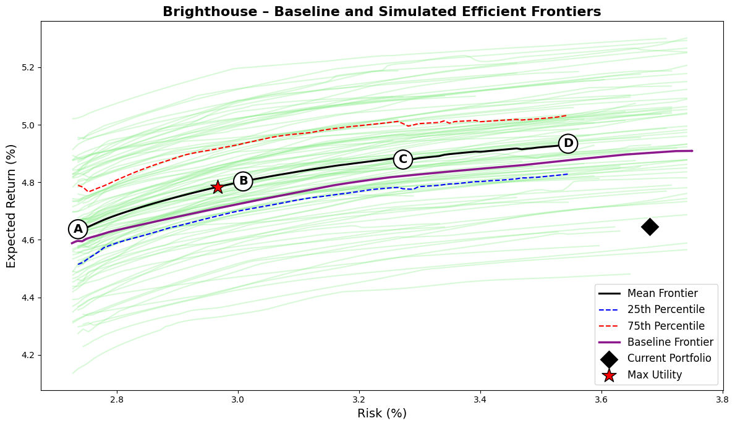
The composition of the efficient frontier portfolios reveals the sources of improvement. Across the robust frontier, the optimizer systematically increases allocations to private placements (A and BBB tranches), residential and commercial mortgage-backed securities (RMBS/CMBS), and residential mortgage whole loans, each approaching their 10 percent concentration limits. These exposures deliver the most attractive return-to-RBC trade-offs, providing incremental yield while maintaining credit quality and liquidity consistent with a long-duration insurer balance sheet. The model correspondingly reduces exposure to commercial mortgage whole loans, which currently represent 13 percent of Brighthouse’s holdings. Whole loans are penalized for their higher borrower concentration and less favorable capital treatment compared with securitized alternatives, leading the optimizer to substitute toward structured credit. It also trims allocations to global ex-U.S. corporates and short-term Treasuries, redirecting weight toward domestic spread assets that offer superior capital efficiency.
Notably, the optimizer does not rely on high-yield bonds or private equity to enhance performance. While these assets provide higher nominal returns, their elevated RBC factors make them inefficient contributors to surplus growth once capital charges are recognized. As a result, their optimized weights remain minimal (below 3-4 percent). Across the efficient portfolios, the average credit rating remains stable between A+ and AA-, while the fixed-income duration extends modestly to 6.8-7.1 years, and overall capital use declines to roughly 1.0 percent. These results demonstrate that meaningful surplus efficiency gains can be achieved within the same qualitative risk and duration framework that Brighthouse already operates under.
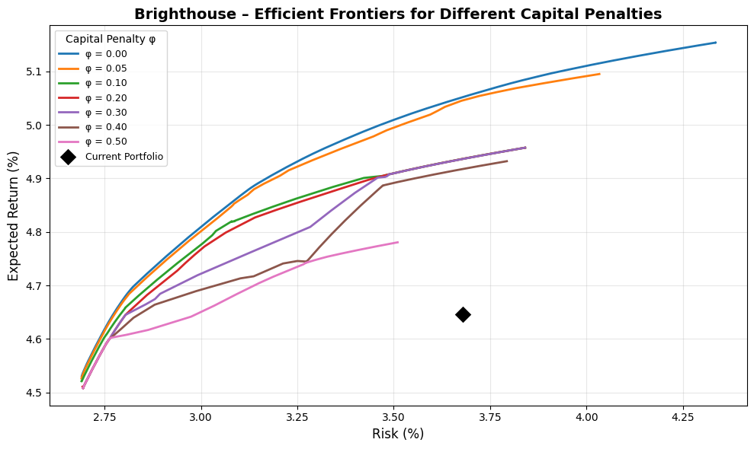
The impact of the capital penalty parameter (phi) further clarifies the relationship between regulatory friction and attainable efficiency. When the penalty is removed (phi=0), the unconstrained frontier reaches expected returns near 5.15 percent at 4 percent volatility, primarily by allocating more heavily to higher-spread, capital-intensive assets such as high-yield credit and private equity. As phi increases, the frontier shifts downward and flattens, favoring capital-efficient sectors. At the realistic base case (phi=0.2), the efficient frontier still dominates the current portfolio, with the utility-maximizing configuration around 3.0 percent risk and 4.9 percent return. Beyond phi=0.4, expected returns decline by roughly 20–25 basis points at comparable risk, as the optimizer concentrates almost entirely in AAA/AA public credit, ABS, and high-grade private placements. The frontier also becomes visibly shorter and kinked as phi rises. This occurs because the capital penalty effectively removes the most capital-intensive assets from the feasible set, causing the optimizer to jump between a small number of discrete efficient combinations rather than tracing a smooth risk-return tradeoff. As higher-phi portfolios cluster around similar low-RBC fixed income segments, the range of feasible volatility narrows, producing a truncated, segmented frontier. This behavior is typical when regulatory capital constraints dominate portfolio dynamics, reinforcing how RBC frictions compress the efficient opportunity set even before liquidity or diversification limits are reached.
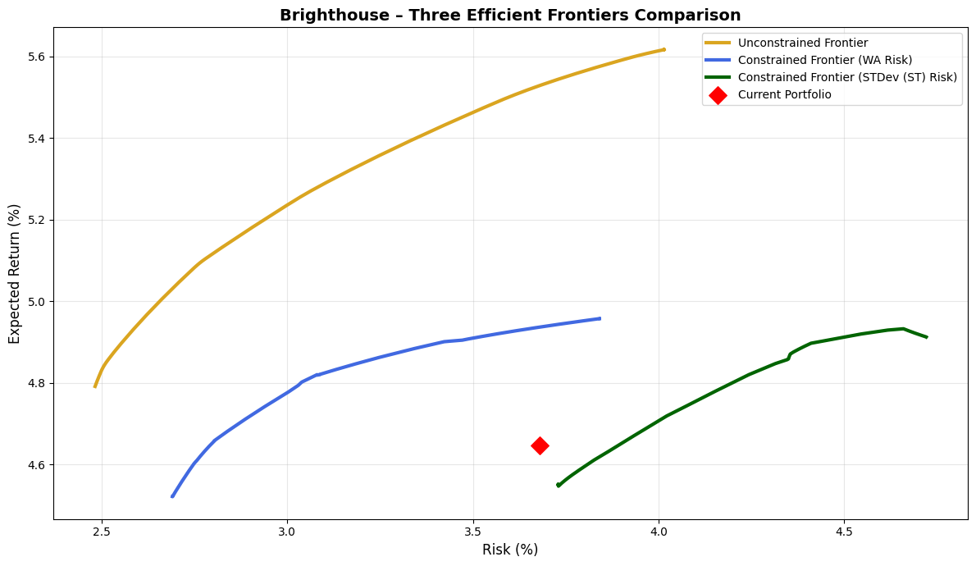
A final comparison between the unconstrained and realistically constrained frontiers quantifies the implementation gap. The unconstrained theoretical frontier lies roughly 70 basis points above the constrained one across the same risk range, largely due to the imposed 10 percent per-asset caps, the no-leverage condition, and the positive capital penalty. Despite these restrictions, Brighthouse’s current allocation remains below even the constrained frontier, confirming that substantial improvement is achievable without relaxing policy limits or increasing balance-sheet risk. The second plot also introduces an additional constrained frontier constructed using the short-term standard deviation (STDEV) as the sole risk measure, in contrast to the weighted-average (WA) measure that combines short-term volatility with long-term uncertainty (RMSE). The WA approach, as discussed earlier, better reflects the multi-horizon risk exposure of life insurers by integrating both market and liability-duration perspectives, while the STDEV frontier captures only short-term mark-to-market sensitivity. The two risk definitions lead to visibly different efficient sets: the WA-based frontier lies further left, emphasizing structural balance-sheet resilience, whereas the STDEV-based frontier appears steeper and more right-shifted, reflecting higher instantaneous volatility but limited duration exposure. Together, these frontiers highlight the tradeoff between short-term accounting volatility and long-term surplus stability. The constrained efficient portfolios, particularly those around 3.0–3.2 percent risk and 4.8 percent return under the WA metric, represent a realistic strategic target consistent with Brighthouse’s liability structure and surplus-management philosophy.
From a strategic perspective, this analysis suggests that Brighthouse could materially enhance surplus efficiency through measured reallocation rather than structural transformation. The optimal adjustments would involve reducing reliance on commercial mortgage whole loans in favor of securitized exposures and private placements, modestly extending portfolio duration toward the seven-year range, and maintaining disciplined exposure to high-RBC sectors. The result is a portfolio that delivers roughly 20 basis points higher expected return, 60 basis points lower risk, and nearly one percentage point less capital usage, while maintaining strong credit quality and liability alignment. In short, Brighthouse’s portfolio is prudently constructed but not positioned on the efficient frontier; by realigning toward the most RBC-efficient sources of yield, it could meaningfully improve long-term surplus generation without compromising solvency resilience.

Corebridge
Corebridge Financial, the former life and retirement division of AIG, has a diversified liability structure spanning individual retirement products, group pensions, and institutional spread-based businesses. Its balance sheet combines retail annuities with large blocks of group retirement and pension-risk-transfer contracts, giving it one of the most balanced liability mixes among U.S. life insurers. The firm’s liability structure is characterized by moderately long duration, meaningful exposure to guaranteed payout obligations, and a stable flow of institutional funding agreements.
To approximate this structure, I modeled Corebridge’s liability profile with 25 percent of expected cash flows in the short bucket, 55 percent in the medium bucket, and 20 percent in the long bucket, corresponding to an average liability duration of about 8.0 years. This allocation reflects its blend of individual and institutional business, where the combination of retail annuities and pension-like exposures produces a moderately longer and more convex liability profile than Brighthouse’s. The higher share of long-duration liabilities implies a somewhat stronger need for asset duration extension and spread stability.
Metric/Asset | Current | Port A | Port B | Port C | Port D | Max Utility
Expected Return (%) | 4.78 | 4.56 | 4.70 | 4.78 | 4.83 | 4.73
Risk (%) | 4.12 | 2.72 | 2.93 | 3.14 | 3.36 | 2.98
Sharpe Ratio | 0.19 | 0.21 | 0.24 | 0.25 | 0.25 | 0.24
Avg FI Credit Rating | A+ | AA- | AA- | AA- | AA- | AA-
FI Duration (years) | 6.18 | 6.53 | 6.52 | 6.55 | 6.57 | 6.52
Net Duration (years) | 0.58 | 0.93 | 0.91 | 0.94 | 0.97 | 0.92
Capital Use (%) | 1.72 | 0.57 | 0.72 | 0.80 | 0.83 | 0.75
US Treasuries, Short/Intermediate | 0.2 | 9.9 | 5.5 | 5.3 | 4.3 | 5.5
US Treasuries, Long | 0.3 | 0.0 | 0.7 | 1.7 | 3.1 | 0.9
US Taxable Munis | 1.9 | 4.9 | 0.4 | 0.2 | 0.1 | 0.3
Global ex-US Government, hedged | 1.8 | 0.0 | 0.0 | 0.0 | 0.0 | 0.0
US Public Corporates IG AAA | 2.8 | 10.0 | 9.9 | 9.7 | 9.5 | 9.9
US Public Corporates IG AA | 5.5 | 9.8 | 7.6 | 6.7 | 5.6 | 7.2
US Public Corporates IG A | 8.3 | 9.7 | 9.8 | 9.8 | 9.6 | 9.7
US Public Corporates IG BBB | 18.8 | 0.2 | 2.5 | 2.9 | 3.1 | 2.4
US Public Corporates, HY Intermediate | 1.3 | 0.0 | 0.2 | 0.7 | 1.2 | 0.4
US Public Corporates, HY Long | 1.6 | 0.0 | 1.8 | 3.0 | 3.2 | 2.3
Global ex-US Corporates, hedged | 0.0 | 10.0 | 8.7 | 4.2 | 0.8 | 8.0
Residential Mortgage-Backed Securities (RMBS) | 6.8 | 6.0 | 10.0 | 9.9 | 10.0 | 10.0
Commercial Mortgage-Backed Securities (CMBS) | 4.1 | 9.2 | 9.6 | 9.8 | 9.6 | 9.6
Asset-Backed Securities (ABS) | 12.8 | 0.1 | 2.7 | 4.9 | 7.1 | 3.1
Corporate IG Private Placement A | 4.5 | 10.0 | 10.0 | 10.0 | 10.0 | 10.0
Corporate IG Private Placement BBB | 5.1 | 10.0 | 10.0 | 10.0 | 10.0 | 10.0
Corporate HY Private (Leveraged Loans) | 0.8 | 0.0 | 0.5 | 0.5 | 0.3 | 0.5
Residential Mortgage Whole Loans | 5.5 | 10.0 | 10.0 | 10.0 | 10.0 | 10.0
Commercial Mortgage Whole Loans | 15.6 | 0.0 | 0.2 | 0.6 | 2.4 | 0.2
Private Equity | 2.5 | 0.2 | 0.0 | 0.0 | 0.0 | 0.0
Real Estate (via partnerships, equity) | 0.0 | 0.0 | 0.0 | 0.0 | 0.0 | 0.0
On the asset side, Corebridge’s general account exhibits a distinctly spread-optimized structure. As of 2025, its portfolio is heavily allocated to public investment-grade credit (35 percent), structured products including ABS, RMBS, and CMBS (approximately 25 percent combined), and private placements (around 10 percent each in A and BBB-rated tranches). The remaining assets are split across commercial mortgage loans, alternative investments, and government securities. The overall composition produces an average fixed-income rating of A+, a duration of 6.2 years, and a modest positive net duration gap of 0.6 years relative to liabilities, indicating that assets are slightly longer than modeled obligations. The modeled capital utilization of 1.7 percent reflects efficient deployment of high-quality spread assets while maintaining regulatory flexibility.
Under my robust optimization framework, Corebridge’s current portfolio appears broadly efficient but still exhibits measurable suboptimality relative to the simulated frontier. The current mix, with an expected return of 4.78 percent and volatility of 4.12 percent, lies below both the baseline and mean efficient frontiers. The optimizer identifies several alternative portfolios that achieve meaningfully higher efficiency: for instance, Portfolios B through D deliver expected returns between 4.7 and 4.83 percent with substantially lower volatility in the 2.9–3.4 percent range. The maximum-utility portfolio, which balances expected return against surplus variance at λ=8, achieves a 4.73 percent return with 2.98 percent risk, improving the Sharpe ratio from 0.19 in the current allocation to approximately 0.24. These results imply that Corebridge’s current mix could realize a 100–120 basis point reduction in surplus volatility while maintaining roughly the same expected return.
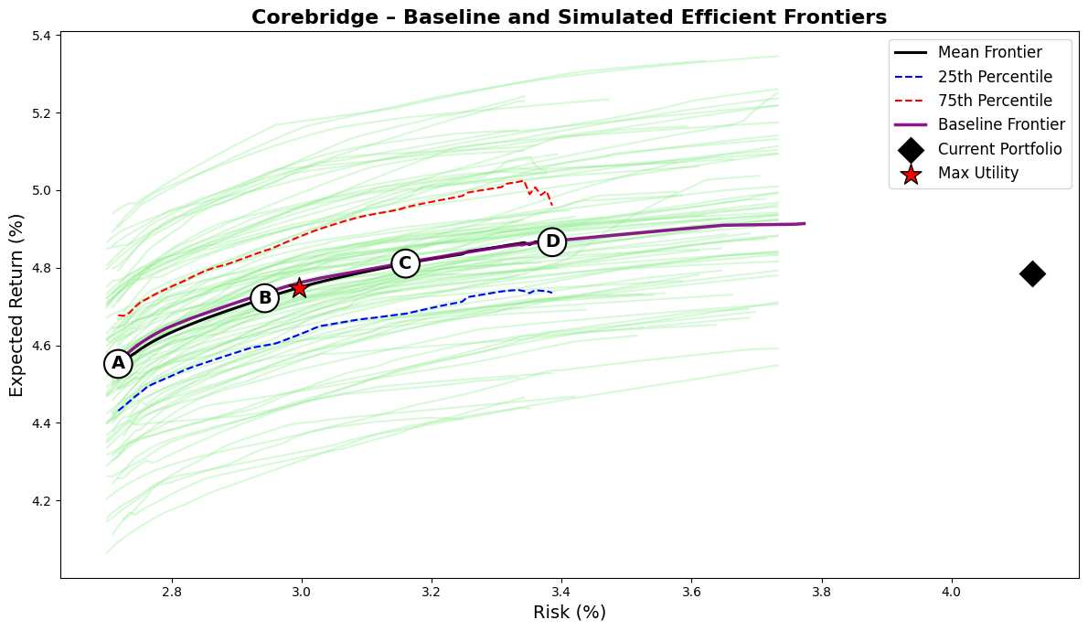
The structure of the optimized portfolios reveals where these gains originate. Across the frontier, the optimizer significantly reduces exposure to BBB-rated public corporates (from nearly 19 percent to below 3 percent) and reallocates toward higher-rated investment-grade credit and structured spread assets. Allocations to A and AA-rated public corporates increase, while private placements and securitized assets such as RMBS, CMBS, and residential mortgage loans reach their 10 percent caps. These sectors combine strong spreads with favorable capital treatment, enhancing surplus efficiency. The optimizer also cuts commercial mortgage whole loans, a 15.6 percent current position, replacing them with securitized alternatives that deliver comparable yield with lower capital intensity.
Unlike Brighthouse, Corebridge’s optimizer retains limited positions in global ex-U.S. corporates and Treasuries to preserve liquidity and rate sensitivity, consistent with its institutional liability mix. Non-core holdings such as global sovereigns, private equity, and real estate are eliminated due to weak capital-adjusted returns. As a result, capital use declines from 1.72 percent to about 0.75 percent, marking a 55 percent improvement in efficiency with no loss in return or duration alignment. The efficient frontier for Corebridge is flatter than Brighthouse’s, reflecting its already optimized exposure to high-quality spread assets. However, the 25th–75th percentile spread of roughly 40 basis points shows continued sensitivity to return and correlation assumptions, particularly for structured and private credit. The mean and baseline frontiers indicate that expected returns of 4.75–4.80 percent are attainable at 3 percent risk, whereas the current portfolio, at over 4 percent risk, remains well inside the efficiency envelope.

MetLife
MetLife’s balance sheet reflects its role as one of the largest and most diversified global life insurers, with a liability structure spanning institutional pension-risk-transfer (PRT) contracts, group benefits, and retail annuities. This mix results in a longer and more convex liability profile than most peers. The company’s liabilities are heavily influenced by pension and corporate benefit obligations, which exhibit long-term payout characteristics and limited optionality, combined with stable blocks of individual annuities and investment-oriented universal life. As a result, MetLife’s average liability duration is modeled around 8.5 years, higher than Brighthouse or Corebridge, with a broad tail extending beyond 20 years that captures its institutional and PRT exposures.
To approximate this profile, I modeled MetLife’s liability curve with 25 percent of cash flows in the short bucket, 50 percent in the medium bucket, and 25 percent in the long bucket, reflecting its diversified yet long-biased obligations. The liability convexity is notably higher than that of Corebridge or Brighthouse, suggesting greater exposure to reinvestment and long-term yield risk. This structure implies that MetLife’s asset allocation strategy must balance long-duration yield capture against capital efficiency and reinvestment flexibility.
Metric/Asset | Current | Port A | Port B | Port C | Port D | Max Utility
Expected Return (%) | 4.50 | 4.55 | 4.72 | 4.81 | 4.87 | 4.71
Risk (%) | 3.71 | 2.71 | 2.98 | 3.25 | 3.50 | 2.97
Sharpe Ratio | 0.13 | 0.20 | 0.24 | 0.25 | 0.25 | 0.24
Avg FI Credit Rating | AA- | AA- | AA- | AA- | AA- | AA-
FI Duration (years) | 6.15 | 6.57 | 6.63 | 6.88 | 7.07 | 6.62
Net Duration (years) | -0.21 | 0.21 | 0.27 | 0.53 | 0.71 | 0.26
Capital Use (%) | 2.63 | 0.56 | 0.74 | 0.78 | 0.81 | 0.73
US Treasuries, Short/Intermediate | 4.0 | 9.9 | 4.5 | 2.9 | 1.7 | 4.5
US Treasuries, Long | 3.9 | 0.0 | 1.3 | 4.6 | 7.5 | 1.3
US Taxable Munis | 2.4 | 5.5 | 0.8 | 0.7 | 0.3 | 0.8
Global ex-US Government, hedged | 10.3 | 0.0 | 0.0 | 0.0 | 0.0 | 0.0
US Public Corporates IG AAA | 1.6 | 10.0 | 10.0 | 10.0 | 9.3 | 10.0
US Public Corporates IG AA | 3.2 | 9.9 | 7.4 | 7.0 | 5.1 | 7.5
US Public Corporates IG A | 4.8 | 9.7 | 9.8 | 9.8 | 9.7 | 9.8
US Public Corporates IG BBB | 3.8 | 0.1 | 3.1 | 3.3 | 3.7 | 3.1
US Public Corporates, HY Intermediate | 0.3 | 0.0 | 0.4 | 0.7 | 0.9 | 0.4
US Public Corporates, HY Long | 0.3 | 0.0 | 1.9 | 3.0 | 3.6 | 1.8
Global ex-US Corporates, hedged | 14.3 | 10.0 | 8.4 | 3.5 | 0.5 | 8.5
Residential Mortgage-Backed Securities (RMBS) | 9.9 | 5.7 | 9.9 | 9.9 | 9.9 | 9.9
Commercial Mortgage-Backed Securities (CMBS) | 2.3 | 9.0 | 9.2 | 9.3 | 9.2 | 9.2
Asset-Backed Securities (ABS) | 5.1 | 0.1 | 2.4 | 3.7 | 5.0 | 2.3
Corporate IG Private Placement A | 4.0 | 10.0 | 10.0 | 10.0 | 10.0 | 10.0
Corporate IG Private Placement BBB | 1.6 | 10.0 | 10.0 | 10.0 | 9.9 | 10.0
Corporate HY Private (Leveraged Loans) | 0.2 | 0.0 | 0.5 | 0.3 | 0.1 | 0.5
Residential Mortgage Whole Loans | 7.0 | 10.0 | 10.0 | 10.0 | 10.0 | 10.0
Commercial Mortgage Whole Loans | 14.0 | 0.0 | 0.4 | 1.3 | 3.6 | 0.4
Private Equity | 3.4 | 0.1 | 0.0 | 0.0 | 0.0 | 0.0
Real Estate (via partnerships, equity) | 3.4 | 0.0 | 0.0 | 0.0 | 0.0 | 0.0
MetLife’s general account investments embody that balance. As of 2025, its portfolio allocates roughly 28 percent to public investment-grade corporates, 27 percent to private credit, 17 percent to structured securities, and over 20 percent to government and sovereign exposures. The remaining 7 percent represents private equity and real estate investments. This blend yields an average fixed-income credit quality of AA-, a duration of 6.2 years, and a small negative net duration gap of -0.2 years relative to the modeled liability book, consistent with the company’s disciplined asset-liability management framework. The modeled capital utilization of 2.6 percent is higher than peers such as Corebridge or Brighthouse, reflecting the company’s broader use of global and long-duration credit exposures, which attract higher RBC charges despite their high quality.
Under my robust optimization framework, MetLife’s current portfolio exhibits moderate inefficiency relative to its efficient frontier. The current mix achieves an expected return of 4.50 percent at 3.71 percent volatility, placing it below both the baseline and mean frontiers. The optimizer identifies several portfolios that achieve superior risk-adjusted performance without increasing capital use. The maximum-utility configuration, corresponding to λ=8, delivers a 4.71 percent expected return at 2.97 percent risk, improving the Sharpe ratio from 0.13 to 0.24 while cutting volatility by nearly 75 basis points. Portfolios C and D, which represent higher-risk points along the frontier, achieve returns up to 4.87 percent with volatility near 3.5 percent, indicating a flatter risk–return slope than in other insurers’ results.
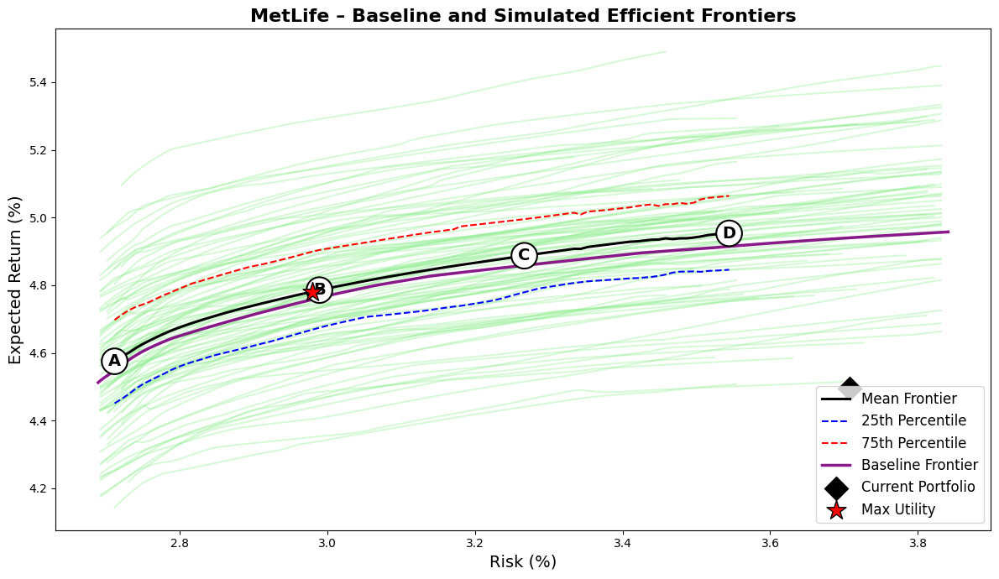
The composition of optimized portfolios highlights how these gains are achieved. The optimizer sharply reduces allocations to lower-efficiency holdings such as global ex-U.S. government bonds (10 percent of the current portfolio) and commercial mortgage whole loans (14 percent), both of which offer limited incremental spread relative to their capital charges. These assets are replaced with higher-yielding, RBC-efficient spread sectors: RMBS and CMBS reach their 10 percent caps, residential mortgage whole loans are maintained at the maximum 10 percent, and private placements (both A and BBB tranches) are fully utilized. Allocations to long Treasuries and long-duration investment-grade credit also increase slightly, better aligning the asset duration with the longer liability term structure. Capital use falls from 2.63 percent to approximately 0.73 percent in the optimized portfolios, reflecting a significant gain in capital efficiency while preserving MetLife’s strong credit profile (AA- average).
MetLife’s efficient frontier is smoother and slightly steeper than those of Brighthouse and Corebridge, consistent with its diversified global exposure and the availability of multiple high-quality spread assets. The optimizer’s simulated frontiers exhibit a relatively tight dispersion, with the 25th to 75th percentile range spanning about 30 basis points of expected return across scenarios. This indicates that the portfolio’s efficiency improvements are not sensitive to small changes in capital market assumptions, but rather stem from structural reallocation toward RBC-efficient sectors.
The improvement in surplus efficiency is accompanied by a modest extension of fixed-income duration from 6.15 to about 6.6–7.1 years and the closure of the duration gap relative to liabilities. Unlike Corebridge or Brighthouse, MetLife’s optimization places less emphasis on reducing total risk and more on aligning the asset and liability profiles while maintaining strong capital discipline. The result is a more balanced surplus risk profile, with roughly one percentage point less capital consumption and about 20 basis points higher expected return at comparable volatility.

Principal
Principal Financial Group’s balance sheet structure reflects its dual identity as both a U.S. life insurer and a global retirement and asset management platform. The company operates with a diversified liability mix that combines individual annuities, institutional retirement plans, and spread-based general account products. This results in a moderately long liability profile, though shorter and less convex than MetLife’s due to Principal’s emphasis on defined-contribution retirement and fixed deferred annuity businesses. In modeling the firm’s liability structure, I allocated 30 percent of cash flows to the short bucket, 55 percent to the medium bucket, and 15 percent to the long bucket, implying an average liability duration of approximately 7.0 years. This reflects its relatively liquid liability base compared to more institutionally oriented peers such as MetLife and Corebridge.
Principal’s general account asset mix exhibits a clear bias toward spread generation within a conservative credit risk framework. As of 2025, the company allocates roughly 34 percent of its portfolio to public investment-grade corporates, 25 percent to private placements, 15 percent to structured products (ABS, CMBS, RMBS), and 13 percent to commercial mortgage loans, with smaller positions in government securities and alternatives. The overall fixed-income portfolio carries an average rating of A+, a duration of 6.5 years, and a modestly positive net duration gap of 0.6 years relative to modeled liabilities. The capital utilization of 2.4 percent is somewhat elevated compared with Brighthouse or Corebridge, reflecting Principal’s larger allocations to BBB-rated public credit and commercial mortgages, both of which attract higher RBC charges despite their stable cash flows.
Metric/Asset | Current | Port A | Port B | Port C | Port D | Max Utility
Expected Return (%) | 4.83 | 4.54 | 4.71 | 4.80 | 4.85 | 4.74
Risk (%) | 3.96 | 2.71 | 2.96 | 3.21 | 3.45 | 3.02
Sharpe Ratio | 0.21 | 0.20 | 0.24 | 0.25 | 0.25 | 0.24
Avg FI Credit Rating | A+ | AA- | AA- | AA- | AA- | AA-
FI Duration (years) | 6.49 | 6.61 | 6.60 | 6.74 | 6.82 | 6.63
Net Duration (years) | 0.56 | 0.68 | 0.67 | 0.82 | 0.90 | 0.70
Capital Use (%) | 2.42 | 0.56 | 0.73 | 0.80 | 0.81 | 0.76
US Treasuries, Short/Intermediate | 0.7 | 9.9 | 4.6 | 3.9 | 2.5 | 4.4
US Treasuries, Long | 0.8 | 0.0 | 0.9 | 3.1 | 5.6 | 1.3
US Taxable Munis | 6.0 | 6.5 | 0.8 | 0.5 | 0.4 | 0.6
Global ex-US Government, hedged | 0.5 | 0.0 | 0.0 | 0.0 | 0.0 | 0.0
US Public Corporates IG AAA | 3.0 | 10.0 | 9.9 | 9.7 | 8.9 | 9.9
US Public Corporates IG AA | 4.5 | 10.0 | 8.1 | 7.0 | 5.2 | 8.0
US Public Corporates IG A | 9.0 | 9.8 | 9.9 | 9.8 | 9.4 | 9.9
US Public Corporates IG BBB | 19.4 | 0.0 | 2.6 | 2.8 | 2.7 | 2.5
US Public Corporates, HY Intermediate | 0.8 | 0.0 | 0.4 | 0.7 | 1.0 | 0.5
US Public Corporates, HY Long | 1.0 | 0.0 | 2.1 | 3.5 | 3.5 | 2.6
Global ex-US Corporates, hedged | 0.0 | 10.0 | 8.5 | 4.3 | 1.1 | 7.9
Residential Mortgage-Backed Securities (RMBS) | 3.6 | 4.9 | 9.9 | 9.9 | 10.0 | 9.9
Commercial Mortgage-Backed Securities (CMBS) | 5.0 | 8.7 | 9.4 | 9.3 | 9.3 | 9.3
Asset-Backed Securities (ABS) | 6.6 | 0.1 | 2.5 | 4.2 | 6.6 | 2.6
Corporate IG Private Placement A | 6.3 | 10.0 | 10.0 | 10.0 | 10.0 | 10.0
Corporate IG Private Placement BBB | 7.4 | 10.0 | 10.0 | 10.0 | 10.0 | 10.0
Corporate HY Private (Leveraged Loans) | 0.7 | 0.0 | 0.3 | 0.2 | 0.1 | 0.3
Residential Mortgage Whole Loans | 6.6 | 10.0 | 10.0 | 10.0 | 10.0 | 10.0
Commercial Mortgage Whole Loans | 13.2 | 0.0 | 0.2 | 1.1 | 3.5 | 0.3
Private Equity | 3.4 | 0.1 | 0.0 | 0.0 | 0.0 | 0.0
Real Estate (via partnerships, equity) | 1.7 | 0.0 | 0.0 | 0.0 | 0.0 | 0.0
Under my robust surplus optimization framework, Principal’s current portfolio appears generally well positioned but not fully efficient. The current mix delivers an expected return of 4.83 percent at 3.96 percent risk, which lies below both the baseline and mean simulated efficient frontiers. The optimizer identifies alternative portfolios that improve either risk-adjusted returns or capital efficiency without materially altering duration or credit quality. The maximum-utility portfolio, at λ=8, achieves an expected return of 4.74 percent at only 3.02 percent volatility, raising the Sharpe ratio from 0.21 to 0.24 while reducing risk by nearly one full percentage point. Portfolios C and D, representing higher-risk configurations, reach expected returns up to 4.85 percent with volatility near 3.4 percent, implying that the company could preserve its return profile while operating with substantially lower surplus volatility.
The optimized allocations illuminate where these gains arise. The optimizer systematically trims Principal’s large holdings of BBB-rated public corporates (19 percent currently) and commercial mortgage whole loans (13 percent) while reallocating toward private placements, securitized assets, and long-duration Treasuries. Both A- and BBB-rated private placements are pushed to their 10 percent caps, reflecting their strong spread-to-capital efficiency. RMBS, CMBS, and residential mortgage whole loans also reach or approach their caps, collectively accounting for nearly 30 percent of the efficient portfolios. These assets provide both yield enhancement and favorable RBC treatment relative to direct commercial loans. Conversely, allocations to ABS decline, as their relatively short duration and modest spread limit their efficiency contribution once other structured sectors are utilized. The optimizer maintains small allocations to long Treasuries and high-grade corporates to control duration and preserve liquidity, while private equity and real estate exposures are largely eliminated given their high capital intensity.
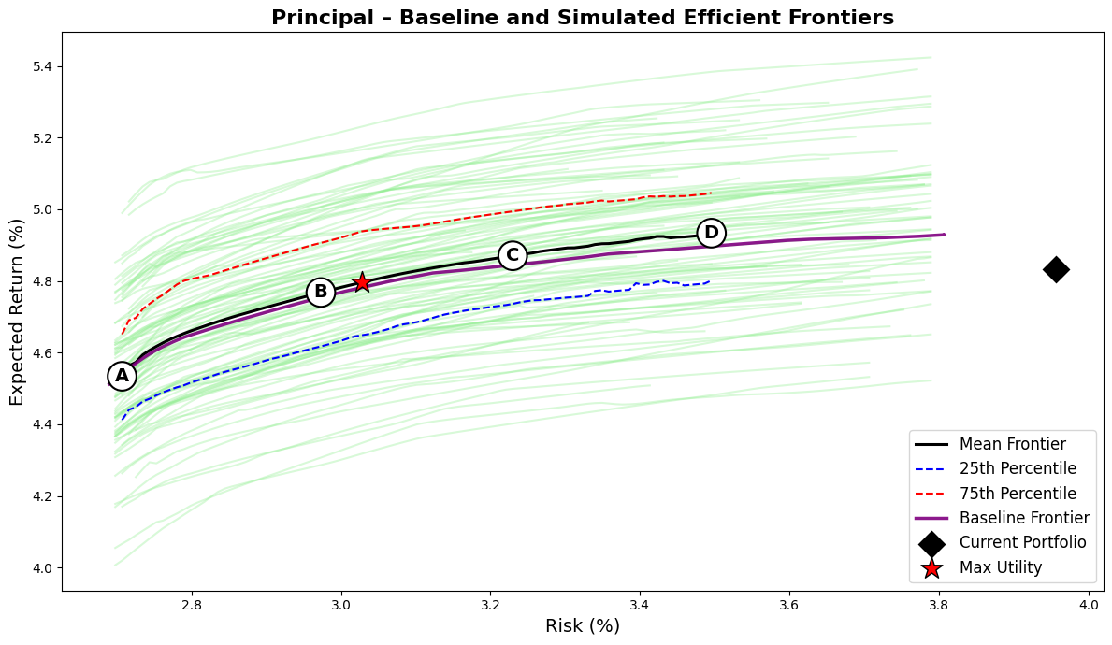
The optimized portfolios demonstrate a pronounced improvement in capital efficiency. Capital use declines from 2.42 percent in the current allocation to around 0.76 percent in the utility-maximizing portfolio, a 70 percent reduction, while the expected return remains nearly unchanged. This shift underscores how much Principal’s surplus efficiency is constrained not by risk appetite but by capital friction embedded in current sector weights. Average credit quality remains at AA-, while fixed-income duration modestly extends to 6.7–6.8 years, better aligning with the modeled liability term structure.
The efficient frontier for Principal exhibits a relatively smooth and steep shape compared with those of Brighthouse or Corebridge, reflecting the firm’s strong diversification across structured and private assets. The interquartile spread of simulated frontiers is tight, roughly ±25 basis points around the mean, suggesting that the efficient configurations are robust to moderate parameter uncertainty. The optimizer’s baseline and mean frontiers closely coincide, indicating that Principal’s opportunity set is well balanced and not excessively sensitive to return estimation noise. Strategically, these findings imply that Principal is close to its efficient frontier but has room for incremental improvement through internal reallocation rather than structural balance-sheet change. The key adjustments would involve shifting exposure from public BBB corporates and commercial mortgages into private placements and securitized assets, modestly extending duration, and reducing concentration in low-efficiency spread sectors. Such a transition would increase surplus stability, reduce capital consumption by roughly 1.5 percentage points, and preserve the company’s conservative credit risk posture.

Prudential
Prudential Financial’s general account reflects its position as one of the most globally diversified and liability-complex life insurers in the U.S. market. The company’s balance sheet supports a mix of individual annuities, group life and retirement contracts, and significant institutional insurance businesses, including pension-risk-transfer and funding agreement operations. This produces a liability structure that is both long-dated and internationally diversified, with exposures across multiple currencies and regulatory regimes. In modeling Prudential’s liability profile, I allocated 20 percent of expected cash flows to the short bucket, 55 percent to the medium bucket, and 25 percent to the long bucket, corresponding to an average liability duration of roughly 8.1 years. This configuration reflects the company’s long-duration annuity and pension obligations combined with more liquid short-term liabilities arising from funding agreements and separate account transfers.
The asset portfolio that backs these liabilities is broad and globally diversified. As of 2025, Prudential allocates approximately 36 percent of its general account to public investment-grade corporates, 20 percent to private placements, 15 percent to structured securities (ABS, RMBS, CMBS), and about 10 percent to commercial mortgage loans. Government securities, including both U.S. Treasuries and global sovereigns, account for 17 percent of total assets, while private equity and real estate collectively represent less than 3 percent. This mix results in an average fixed-income credit rating of AA-, a duration of 6.8 years, and a net duration gap of 1.3 years, meaning the asset base is slightly longer than modeled liabilities. The capital utilization rate of 1.7 percent is among the lowest in the peer group, reflecting the firm’s conservative credit posture and high share of high-grade, capital-efficient exposures.
Metric/Asset | Current | Port A | Port B | Port C | Port D | Max Utility
Expected Return (%) | 4.57 | 4.56 | 4.69 | 4.77 | 4.82 | 4.72
Risk (%) | 3.48 | 2.71 | 2.91 | 3.13 | 3.32 | 2.97
Sharpe Ratio | 0.16 | 0.20 | 0.24 | 0.25 | 0.25 | 0.24
Avg FI Credit Rating | AA- | AA- | AA- | AA- | AA- | AA-
FI Duration (years) | 6.84 | 6.53 | 6.48 | 6.50 | 6.53 | 6.48
Net Duration (years) | 1.27 | 0.97 | 0.91 | 0.94 | 0.97 | 0.92
Capital Use (%) | 1.66 | 0.57 | 0.71 | 0.79 | 0.82 | 0.74
US Treasuries, Short/Intermediate | 2.5 | 9.9 | 5.6 | 5.3 | 3.7 | 5.6
US Treasuries, Long | 2.6 | 0.0 | 0.3 | 0.9 | 1.9 | 0.4
US Taxable Munis | 1.4 | 5.1 | 0.4 | 0.4 | 0.3 | 0.4
Global ex-US Government, hedged | 14.6 | 0.0 | 0.0 | 0.0 | 0.0 | 0.0
US Public Corporates IG AAA | 2.7 | 10.0 | 9.8 | 9.6 | 9.3 | 9.8
US Public Corporates IG AA | 5.4 | 10.0 | 7.9 | 7.2 | 6.8 | 7.4
US Public Corporates IG A | 8.2 | 9.6 | 9.9 | 9.9 | 9.8 | 9.9
US Public Corporates IG BBB | 7.7 | 0.1 | 2.7 | 2.7 | 3.1 | 2.4
US Public Corporates, HY Intermediate | 0.8 | 0.0 | 0.4 | 0.8 | 1.0 | 0.6
US Public Corporates, HY Long | 0.9 | 0.0 | 1.3 | 2.9 | 3.3 | 2.0
Global ex-US Corporates, hedged | 6.0 | 10.0 | 8.8 | 4.9 | 1.6 | 8.1
Residential Mortgage-Backed Securities (RMBS) | 1.0 | 5.7 | 10.0 | 10.0 | 10.0 | 10.0
Commercial Mortgage-Backed Securities (CMBS) | 2.4 | 9.3 | 9.6 | 9.6 | 9.7 | 9.5
Asset-Backed Securities (ABS) | 4.6 | 0.0 | 2.4 | 4.1 | 6.4 | 2.8
Corporate IG Private Placement A | 13.4 | 10.0 | 10.0 | 10.0 | 10.0 | 10.0
Corporate IG Private Placement BBB | 6.3 | 10.0 | 10.0 | 10.0 | 10.0 | 10.0
Corporate HY Private (Leveraged Loans) | 1.4 | 0.0 | 0.5 | 0.4 | 0.3 | 0.5
Residential Mortgage Whole Loans | 5.2 | 10.0 | 10.0 | 10.0 | 10.0 | 10.0
Commercial Mortgage Whole Loans | 10.4 | 0.0 | 0.4 | 1.3 | 2.9 | 0.6
Private Equity | 2.1 | 0.2 | 0.0 | 0.0 | 0.0 | 0.0
Real Estate (via partnerships, equity) | 0.5 | 0.0 | 0.0 | 0.0 | 0.0 | 0.0
Under my robust optimization framework, Prudential’s current portfolio is relatively efficient but not fully optimized. The existing mix achieves an expected return of 4.57 percent with 3.48 percent volatility, placing it slightly below the mean and baseline efficient frontiers. The optimizer identifies several alternative allocations that achieve comparable or higher returns at significantly lower risk. The maximum-utility configuration (λ=8) delivers a 4.72 percent expected return with only 2.97 percent volatility, improving the Sharpe ratio from 0.16 to 0.24 while reducing risk by more than 50 basis points. Portfolios C and D, which operate further along the risk spectrum, reach expected returns up to 4.82 percent with volatility between 3.1 and 3.3 percent, implying that the current portfolio could either increase return by 20–25 basis points or reduce surplus risk by 70–80 basis points without additional capital cost.
The composition of the efficient frontier portfolios highlights how these improvements are achieved. The optimizer reduces Prudential’s exposure to lower-return, high-capital sectors such as global ex-U.S. government bonds (currently 14.6 percent of the portfolio) and reallocates that capital toward structured credit and private placements. RMBS, CMBS, and residential mortgage whole loans each reach their 10 percent caps across the efficient portfolios, reflecting their superior return-to-capital characteristics. Both A- and BBB-rated private placements are fully utilized, and allocations to BBB-rated public corporates decline from nearly 8 percent to less than 3 percent. Long-duration Treasuries and AAA/AA-rated public corporates remain present to manage duration and maintain liquidity, while higher-capital sectors such as private equity and real estate are minimized.
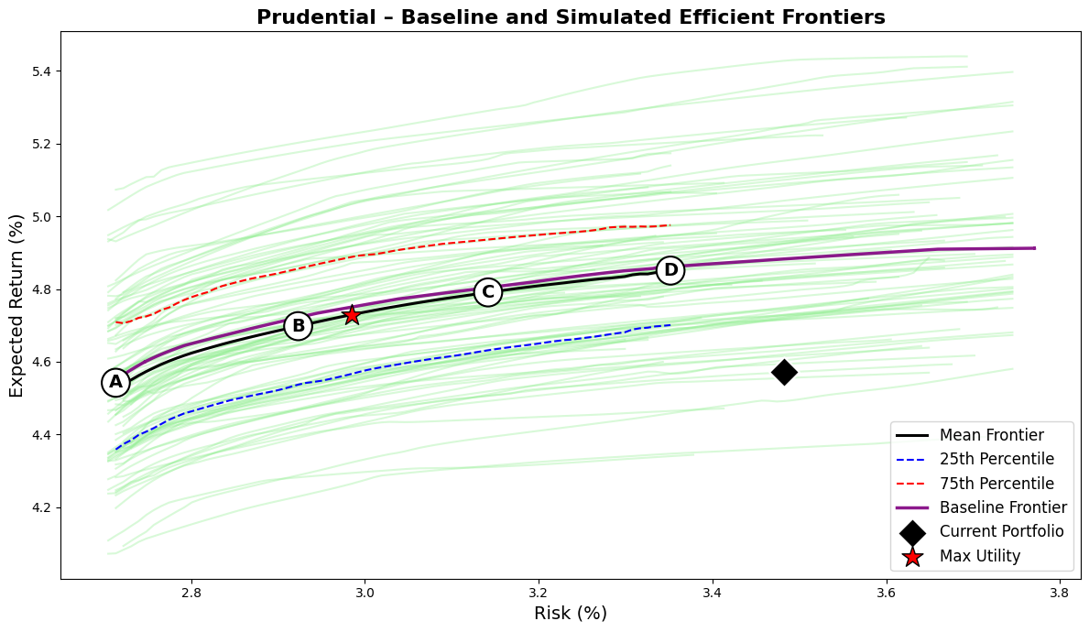
A notable feature of Prudential’s optimization results is the stability of capital efficiency across the frontier. Despite material changes in asset composition, capital use remains between 0.7 and 0.8 percent across all optimized portfolios, down from 1.7 percent currently. This reflects the firm’s inherently capital-efficient balance sheet, where a shift from global sovereigns to structured U.S. spread assets unlocks further surplus efficiency without increasing aggregate risk. The average credit quality remains at AA-, and fixed-income duration remains stable around 6.5 years, slightly improving liability alignment while preserving Prudential’s conservative risk posture.
The efficient frontier for Prudential is smoother and slightly flatter than those of Principal or Corebridge. The interquartile spread between the 25th and 75th percentile simulated frontiers is narrow (about ±20 basis points), indicating that the company’s opportunity set is relatively robust to model uncertainty. The mean and baseline frontiers nearly coincide, underscoring the stability of Prudential’s risk-return trade-off even under parameter perturbations. Strategically, the analysis suggests that Prudential’s general account is already close to an efficient surplus configuration but could still enhance performance through targeted reallocations. The largest opportunities lie in reducing global sovereign exposure and marginally trimming lower-yielding BBB public credit in favor of structured and private spread assets. These adjustments would modestly raise expected return, lower surplus volatility, and reduce capital usage, all without compromising duration matching or credit quality.

Voya
Voya Financial’s general account structure reflects its evolution from a traditional life insurance company into a retirement and asset management–focused institution. The firm’s liability profile is relatively short and liquid compared with other large U.S. life insurers, driven by its emphasis on defined contribution retirement products, fixed annuities, and funding agreement–backed securities (FABS). These lines of business produce a liability term structure with modest convexity and shorter average duration. I modeled Voya’s liabilities as having 35 percent of expected cash flows in the short bucket, 50 percent in the medium bucket, and 15 percent in the long bucket, corresponding to an average liability duration near 6.5 years. This configuration captures the company’s liquidity-sensitive funding model and its lower exposure to long-dated guarantees relative to peers like Prudential and MetLife.
Voya’s investment portfolio is well diversified across fixed income sectors but designed primarily for capital efficiency and liquidity management rather than maximum yield. As of 2025, its general account is composed of approximately 33 percent public investment-grade corporates, 21 percent private placements, 17 percent structured securities (RMBS, CMBS, and ABS), 10 percent commercial mortgage loans, and 17 percent in government securities. The remainder, roughly 5 percent, is invested in alternatives such as private equity and real estate. This allocation produces an average fixed-income rating of AA-, a duration of 6.2 years, and a net duration gap of 0.3 years, indicating close alignment with its liability profile. The modeled capital use of 2.2 percent is moderately high given Voya’s exposure to BBB-rated credit and structured assets but consistent with its spread-driven business model.
Metric/Asset | Current | Port A | Port B | Port C | Port D | Max Utility
Expected Return (%) | 4.82 | 4.55 | 4.71 | 4.80 | 4.85 | 4.72
Risk (%) | 3.62 | 2.71 | 2.96 | 3.21 | 3.45 | 2.99
Sharpe Ratio | 0.23 | 0.20 | 0.24 | 0.25 | 0.25 | 0.24
Avg FI Credit Rating | AA- | AA- | AA- | AA- | AA- | AA-
FI Duration (years) | 6.20 | 6.56 | 6.63 | 6.74 | 6.79 | 6.65
Net Duration (years) | 0.31 | 0.67 | 0.74 | 0.85 | 0.90 | 0.76
Capital Use (%) | 2.16 | 0.57 | 0.71 | 0.79 | 0.81 | 0.73
US Treasuries, Short/Intermediate | 0.7 | 10.0 | 4.1 | 4.0 | 3.0 | 4.0
US Treasuries, Long | 0.9 | 0.0 | 1.2 | 3.3 | 5.2 | 1.4
US Taxable Munis | 1.4 | 5.3 | 0.8 | 0.6 | 0.4 | 0.8
Global ex-US Government, hedged | 3.4 | 0.0 | 0.0 | 0.0 | 0.0 | 0.0
US Public Corporates IG AAA | 1.4 | 10.0 | 9.8 | 9.8 | 9.0 | 9.8
US Public Corporates IG AA | 4.0 | 9.8 | 8.5 | 6.9 | 5.5 | 8.3
US Public Corporates IG A | 5.1 | 9.8 | 9.8 | 9.7 | 9.5 | 9.8
US Public Corporates IG BBB | 8.3 | 0.2 | 2.7 | 2.8 | 2.8 | 2.7
US Public Corporates, HY Intermediate | 0.5 | 0.0 | 0.4 | 0.8 | 0.9 | 0.4
US Public Corporates, HY Long | 0.6 | 0.0 | 1.8 | 3.2 | 3.5 | 2.0
Global ex-US Corporates, hedged | 6.8 | 10.0 | 8.4 | 3.9 | 0.7 | 8.1
Residential Mortgage-Backed Securities (RMBS) | 9.9 | 5.8 | 10.0 | 10.0 | 10.0 | 10.0
Commercial Mortgage-Backed Securities (CMBS) | 8.1 | 8.9 | 9.3 | 9.4 | 9.4 | 9.3
Asset-Backed Securities (ABS) | 7.9 | 0.1 | 2.6 | 4.2 | 6.0 | 2.7
Corporate IG Private Placement A | 11.6 | 10.0 | 10.0 | 10.0 | 10.0 | 10.0
Corporate IG Private Placement BBB | 9.2 | 10.0 | 10.0 | 10.0 | 10.0 | 10.0
Corporate HY Private (Leveraged Loans) | 1.2 | 0.0 | 0.3 | 0.3 | 0.2 | 0.3
Residential Mortgage Whole Loans | 4.9 | 10.0 | 10.0 | 10.0 | 10.0 | 10.0
Commercial Mortgage Whole Loans | 9.8 | 0.0 | 0.2 | 1.3 | 4.0 | 0.3
Private Equity | 4.5 | 0.1 | 0.0 | 0.0 | 0.0 | 0.0
Real Estate (via partnerships, equity) | 0.0 | 0.0 | 0.0 | 0.0 | 0.0 | 0.0
Under my robust surplus optimization framework, Voya’s current portfolio exhibits mild sub-efficiency. The existing mix achieves an expected return of 4.82 percent at 3.62 percent volatility, placing it slightly inside both the baseline and mean efficient frontiers. The optimizer identifies portfolios that achieve equivalent returns with materially lower risk or modestly higher returns at similar risk. The maximum-utility portfolio (λ=8) achieves an expected return of 4.72 percent with only 2.99 percent volatility, improving the Sharpe ratio from 0.23 to 0.24 while reducing risk by over 60 basis points. Portfolios C and D deliver returns up to 4.85 percent at risk levels between 3.2 and 3.5 percent, confirming that Voya’s current positioning is close to efficient but not fully optimal.
The optimized portfolios reveal a consistent reallocation pattern that enhances both capital efficiency and liability matching. The optimizer significantly reduces allocations to commercial mortgage whole loans (9.8 percent currently) and BBB-rated public corporates (8.3 percent), redirecting this exposure toward private placements and structured credit. Both A- and BBB-rated private placements are fully utilized at their 10 percent caps, providing an attractive balance between yield and RBC efficiency. RMBS, CMBS, and residential mortgage whole loans are also pushed near their caps, reflecting their favorable capital treatment and yield contribution. Conversely, global ex-U.S. corporates and sovereigns are largely eliminated, as they offer limited incremental return relative to their correlation and capital costs. Small allocations to long Treasuries are retained to manage duration and provide liquidity.
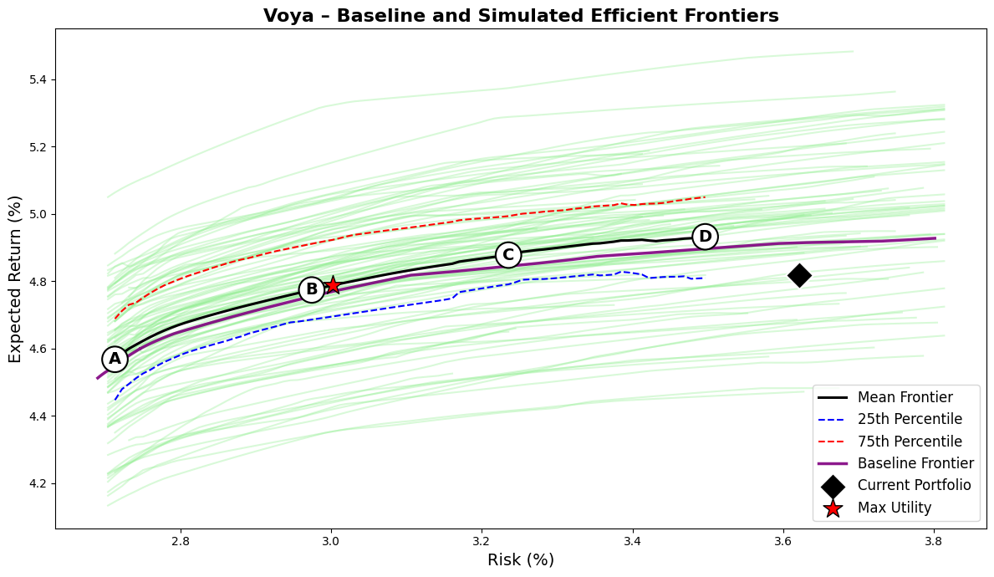
Across the efficient frontier, Voya’s portfolios maintain high credit quality (AA-), modestly extend fixed-income duration to around 6.7–6.8 years, and achieve a sharp improvement in capital efficiency. Capital use declines from 2.16 percent to roughly 0.73 percent in the optimized configurations, while expected returns remain nearly unchanged. The interquartile range of simulated frontiers is narrow, about ±25 basis points, suggesting that these improvements are robust to parameter uncertainty. The mean and baseline frontiers are closely aligned, confirming that the firm’s diversified spread base provides stable efficiency characteristics under plausible perturbations of market assumptions.
Strategically, these results indicate that Voya’s general account is already positioned near the efficient frontier but could capture incremental surplus efficiency through selective adjustments. The main opportunities lie in reducing exposure to capital-intensive commercial mortgage loans and BBB-rated public credit, reallocating that capital to private placements and structured spread sectors. Such adjustments would reduce surplus volatility, enhance capital efficiency, and maintain duration alignment with liabilities. The resulting configuration would preserve Voya’s conservative credit profile while improving expected surplus growth and capital deployment efficiency. Overall, Voya’s portfolio embodies a disciplined, risk-controlled balance between liquidity and spread income, consistent with its liability profile and retirement-focused business model, but it remains slightly short of the theoretical efficiency frontier achievable within its existing constraints.

Factor Analysis and Asset/Liability Simulation
This stage extends the analysis beyond static optimization to evaluate how portfolios perform under changing economic and market conditions. The goal is to connect each asset’s risk and return characteristics to common systematic drivers, simulate their joint evolution with liabilities, and assess long-term surplus outcomes.
A multi-factor framework was estimated using monthly historical data on macro-financial variables and asset excess returns. Each asset was regressed on four standardized factors: changes in the risk-free rate level (ΔL), changes in the yield-curve slope (ΔS), changes in investment-grade credit spreads (SprIG), and equity market excess returns (E). These factors capture the main channels through which macro conditions affect insurers’ portfolios—interest rate shifts, curve movements, credit spread behavior, and equity risk sensitivity.
Multicollinearity diagnostics ensured factor stability before estimation. Ordinary least squares regressions with Newey–West (HAC) standard errors were then used to correct for serial correlation in monthly returns. Only statistically significant coefficients (p < 0.10) were retained, ensuring that the estimated betas reflect robust and economically meaningful relationships. Residual standard deviations were stored as idiosyncratic volatilities to be used in the simulation stage.
To account for changing macro-financial environments, factor covariances were estimated separately for two regimes defined by the 36-month rolling correlation between ΔL and E. Periods with positive correlation were classified as normal (typical disinflationary conditions), while periods with negative correlation were classified as inflationary (stock-bond co-movement). This captures how diversification benefits vary across market states, a key consideration for insurers exposed to both rate and credit risk.
Expected asset returns from the optimization stage were combined with the estimated betas and regime-dependent covariances to form the stochastic simulation model. Asset returns were generated according to
$$r_{asset}=μ+β^{'}F+ε$$
where $μ$is the expected monthly return, $β$is the vector of significant factor loadings, $F$represents factor shocks drawn from regime-specific covariance matrices, and $ε$is the idiosyncratic noise term.
Liability returns were modeled as a function of accrual rate and sensitivity to rate level and slope changes:
$$r_{liability}=accrual+β_{AL}⋅ΔL+β_{dS}⋅ΔS$$
Liability parameters were company-specific, derived from each firm’s duration and liquidity profile. This ensures that asset and liability movements are internally consistent within each simulation path.
The model simulated asset and liability values jointly over 10,000 Monte Carlo paths and a 10-year horizon (120 months). Each simulation randomly transitioned between normal and inflationary regimes based on their historical probabilities, producing realistic distributions of asset, liability, and surplus outcomes.
Three metrics summarize the results:
- H1 (Surplus Growth): Median surplus compound annual growth rate (CAGR) over the 10-year horizon.
- H2 (Shortfall Risk): Probability that surplus becomes negative, and probability that surplus CAGR falls below the liability discount rate.
- H3 (RBC Efficiency): Median surplus CAGR per unit of regulatory capital, measuring surplus generated per unit of required capital.
Results across all six insurers show consistent patterns. RMSE-based (robust) optimized portfolios achieve higher surplus growth, lower shortfall risk, and greater RBC efficiency compared with volatility-minimizing portfolios. Improvements in surplus CAGR averaged 10–13 basis points, shortfall probabilities declined by about 2 percentage points, and surplus per unit of capital increased by roughly 0.15–0.20.
Company | Δ Surplus CAGR (RMSE–VOL) | Δ P(Surplus<0) | Δ Surplus/RBC
Brighthouse | +0.10% | −2.3 pp | +0.13
Corebridge | +0.12% | −2.3 pp | +0.17
MetLife | +0.10% | −1.5 pp | +0.17
Principal | +0.13% | −2.2 pp | +0.16
Prudential | +0.11% | −1.9 pp | +0.15
Voya | +0.11% | −1.6 pp | +0.19
The observed improvement in surplus efficiency stems from the way the RMSE-based risk measure captures long-term uncertainty alongside short-term volatility. While both approaches use the same optimization framework and constraints, the RMSE metric penalizes persistent deviations from expected returns more heavily than short-term fluctuations. As a result, portfolios optimized under this measure favor assets with more stable long-horizon performance and lower parameter sensitivity, such as high-quality spread assets and diversified securitized exposures. In contrast, optimization based solely on standard deviation tends to overweight assets that appear low-risk in the short term but may exhibit higher uncertainty or drawdown potential over time.
Economically, this distinction aligns with how life insurers actually experience and manage risk. Their surplus dynamics depend on sustained return consistency rather than month-to-month volatility. By integrating long-term model uncertainty into the risk definition, the RMSE framework produces portfolios that are better aligned with liability horizons and more resilient to shifts in the underlying return distribution. Mathematically, this also leads to smoother and more stable frontier shapes, as the RMSE term dampens extreme sensitivity to parameter estimation error while still preserving mean-variance efficiency.

